**Docker Deep Dive**

**1. Bad Old Days:**

* We are going to study how to containerize any application.
* Book by Nigel Poulton;
* In old days, one application per server 🡪 lack of technical resources and knowledge.
* 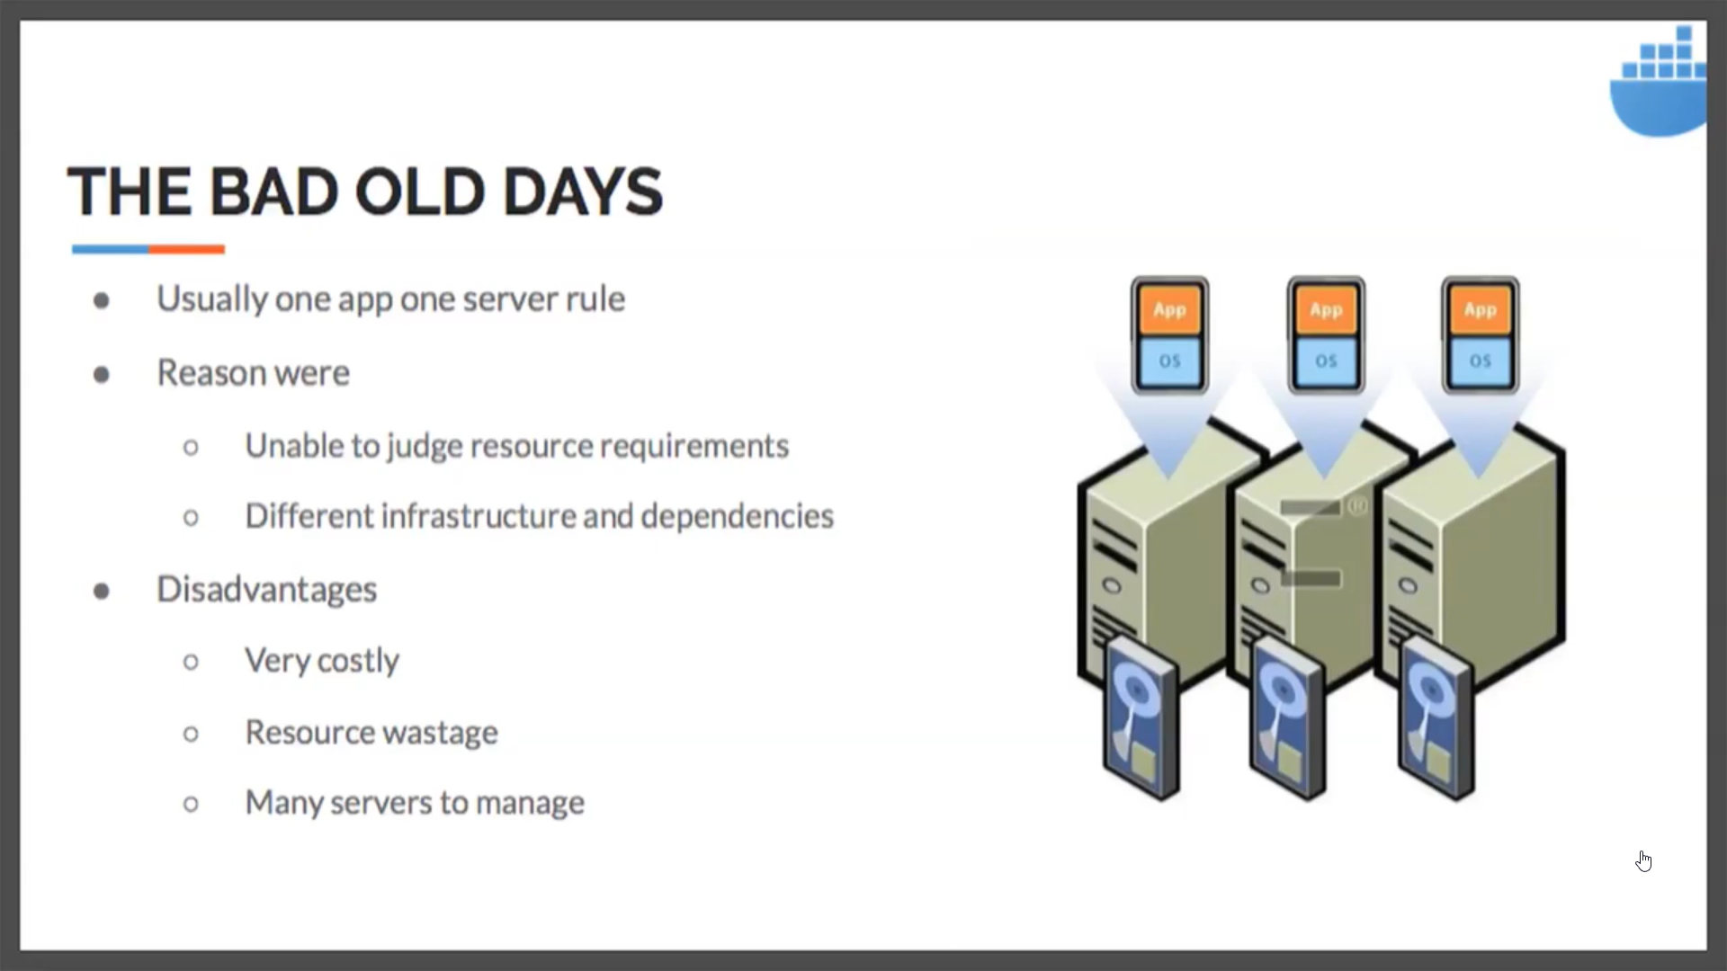
* Old days application deployment strategy had many disadvantages as listed above.
* In 1998, VMware technology allowed us to deploy more than one application on a single server through virtualization.
* Through virtualization, different OS and dependencies can be installed on different virtual instances on a single server without impacting other virtual instances.
* Disadvantage of virtualization: Not only each virtual instance required lots of physical resources, but also the OS of the server also required its own resources and dependencies. Hence, a lot of resources were being consumed since each virtual instance had its own OS and dependencies.
* 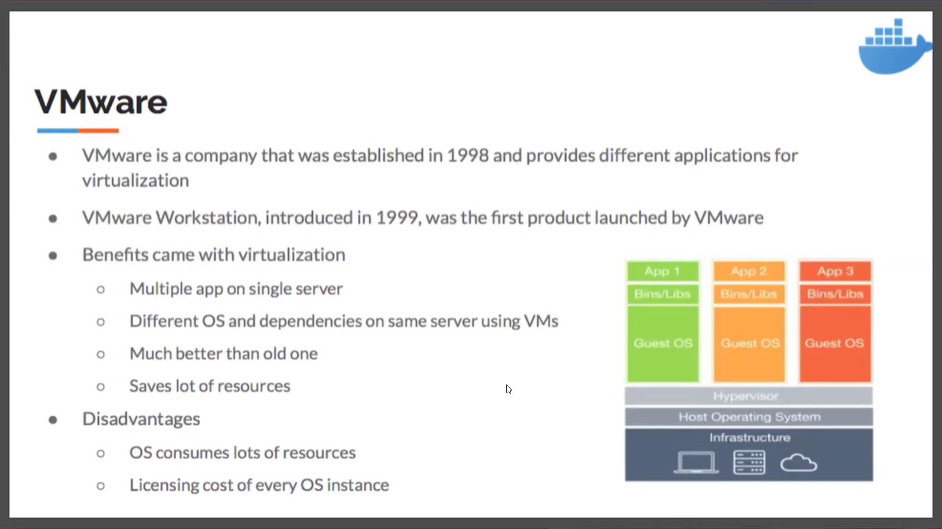
* The OS on each virtual instance required its own licensing fees, excluding Linux, which increased licensing cost significantly. For example, if there are four virtual instances that requires windows as OS, licensing fees will be charged separately for each instance.
* 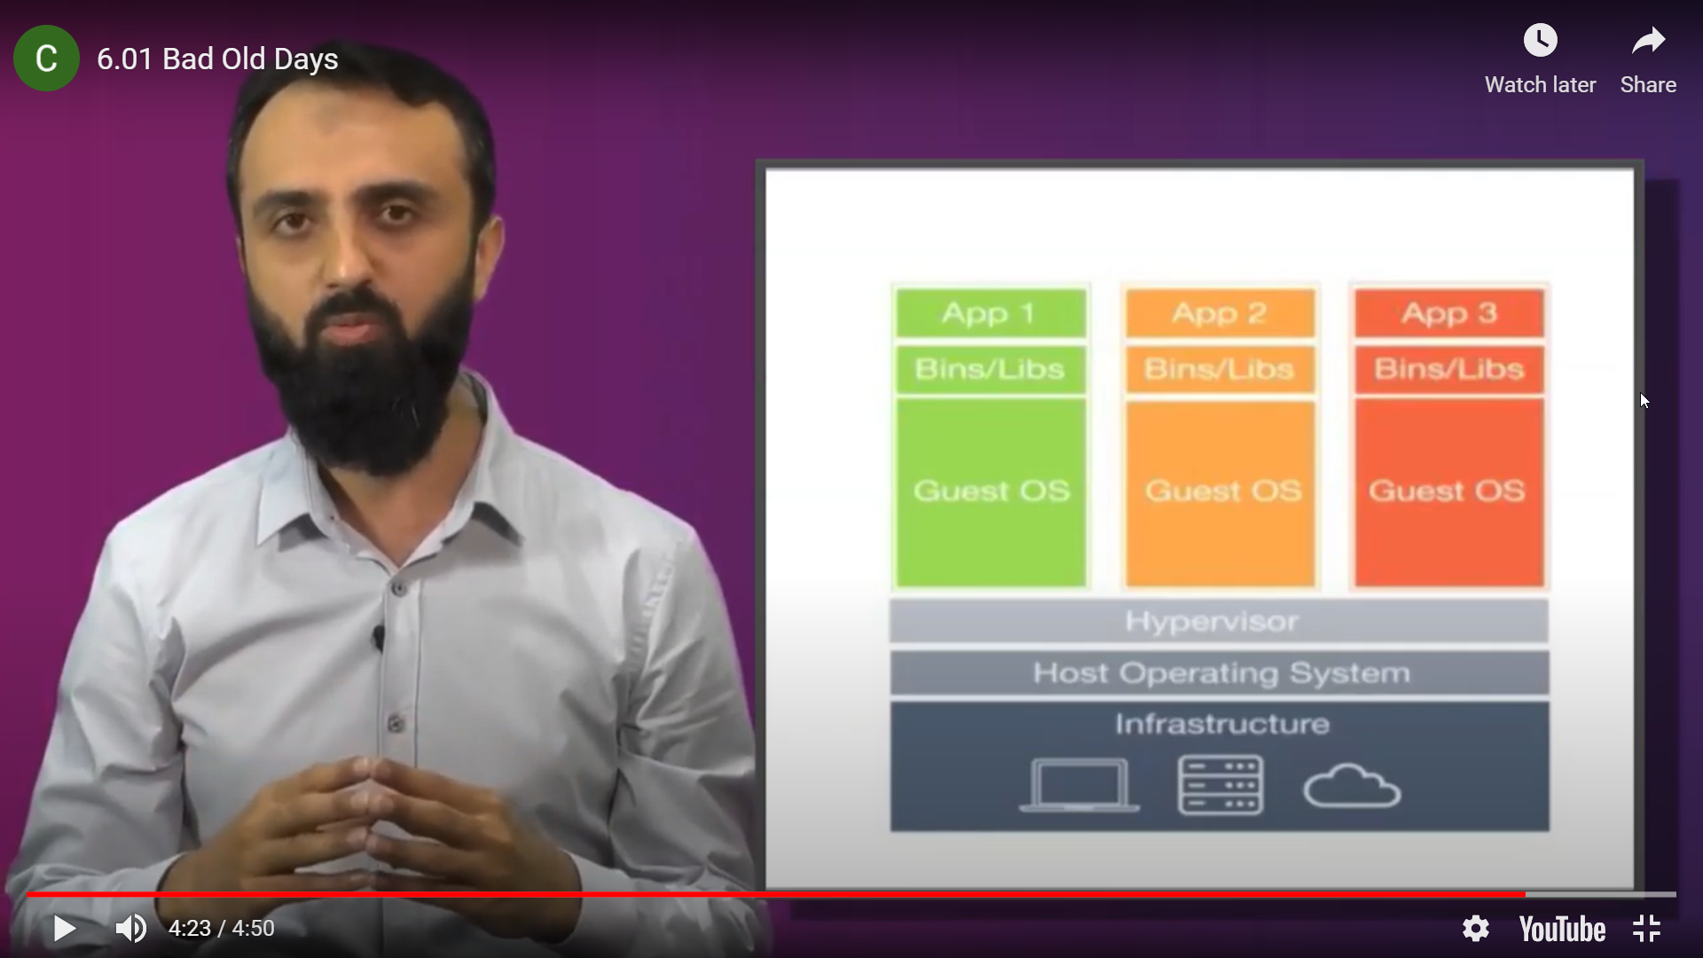
* Base OS to control our infrastructure 🡪 That is connected with Server/host OS 🡪 Hypervisor layer 🡪 Guest OS virtualized as virtual instances.
* As you can see above, we have our own infrastructure with **base Operating System**. Upon which we have our **Server/Host OS**, on which we can virtualize several **Guest OS**’sas virtual instances that can be installed. But between the former two is sandwiched a layer called **Hypervisor**. This hypervisor layer separates the server/host OS and applications (virtual instances) from the base OS so that the host/server OS could independently operate the virtual instances as guests and the compute resources of the host/server can be shared with the virtual machines.
* ☝ This is the VM Model.
* 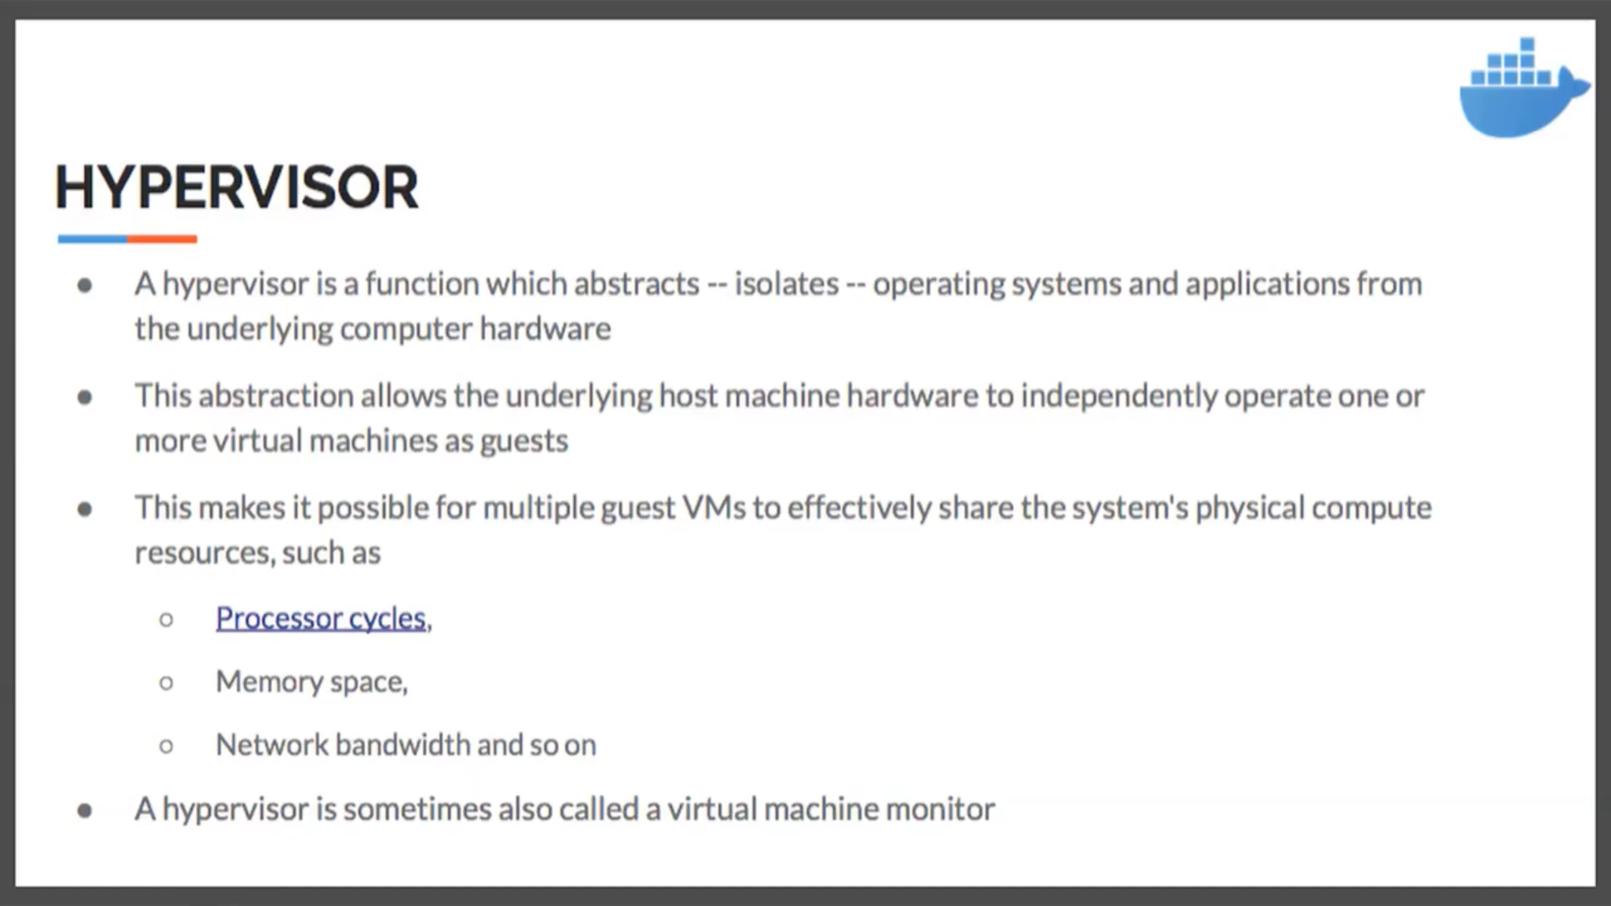

**2. Container Technology:**

* 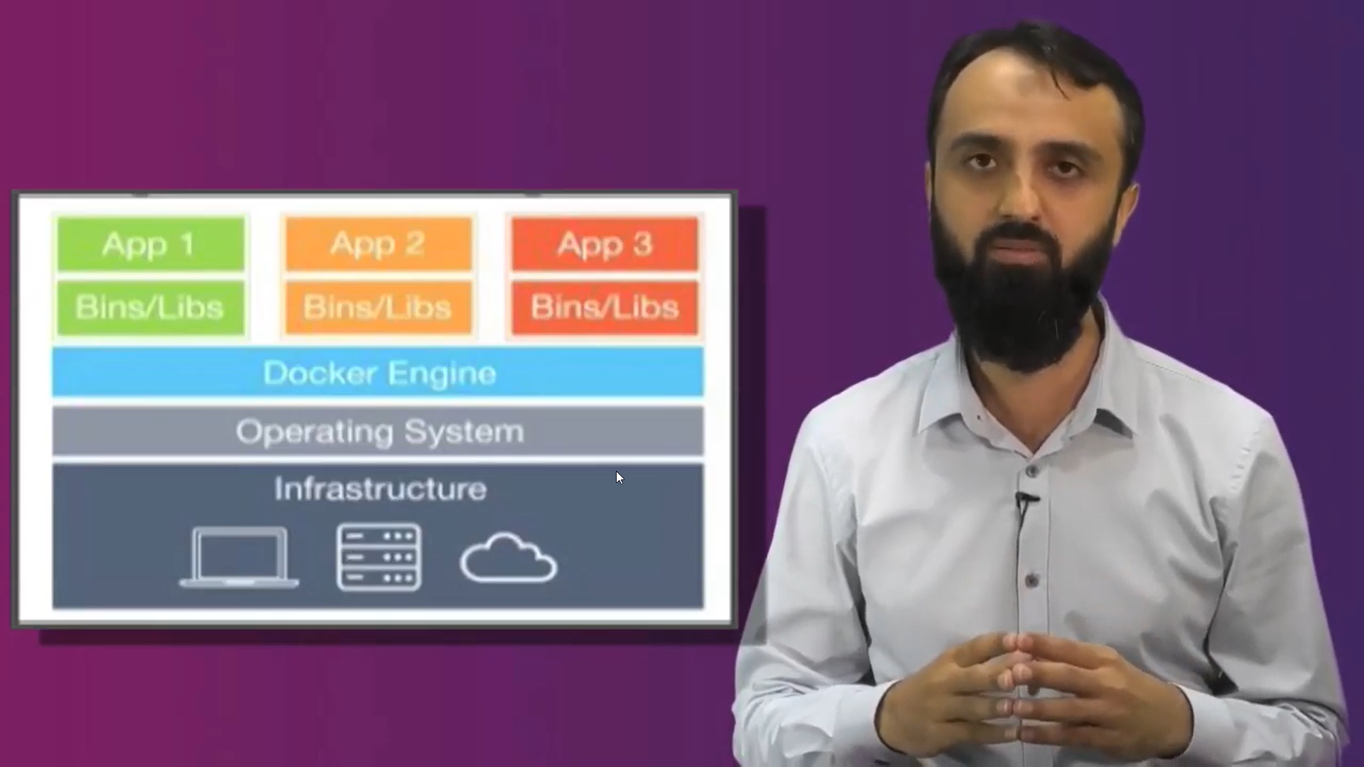
* Infrastructure (Laptop/Systems/Servers) 🡪 Above them is OS 🡪 Right on the Operating System, we install a layer of Docker Engine. Docker Engine allows us to run the applications using the Server OS without any need to completely install Operating Systems.
* Difference between Containerized Architecture and VM Model: In VM Model, we install several Guest Operating systems to support our application while in containerized architecture, the only OS involved in supporting the applications is the OS of the system/laptop/server.
* 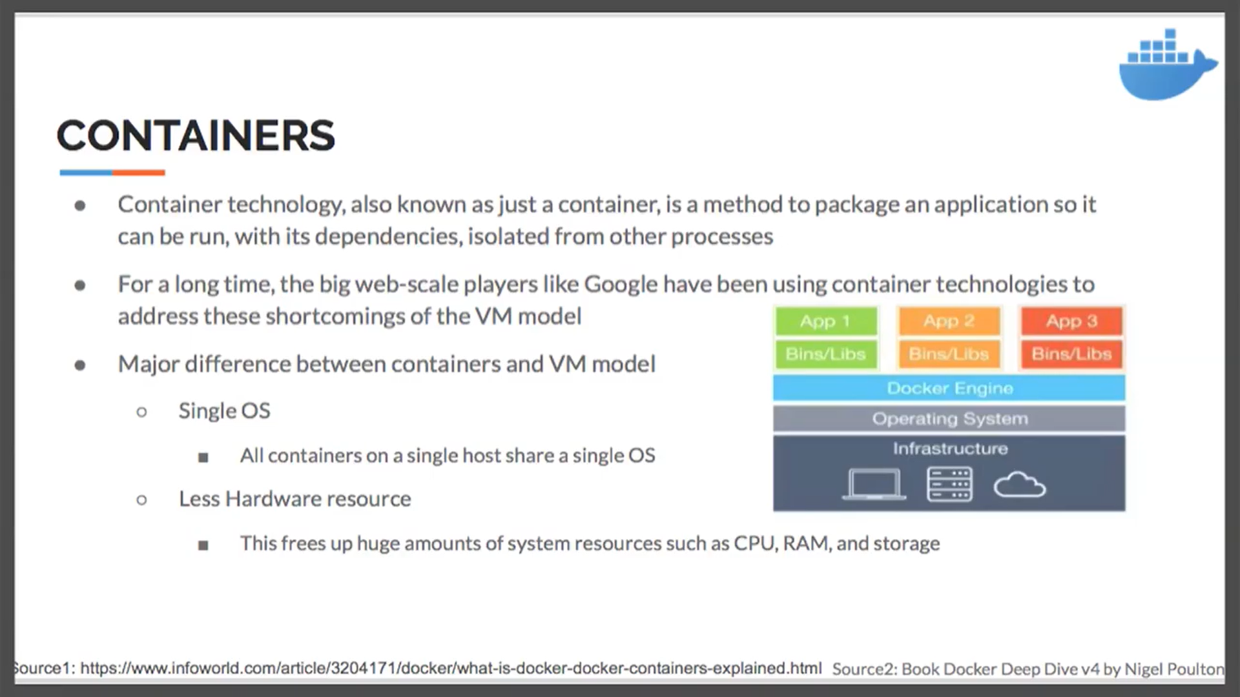
* 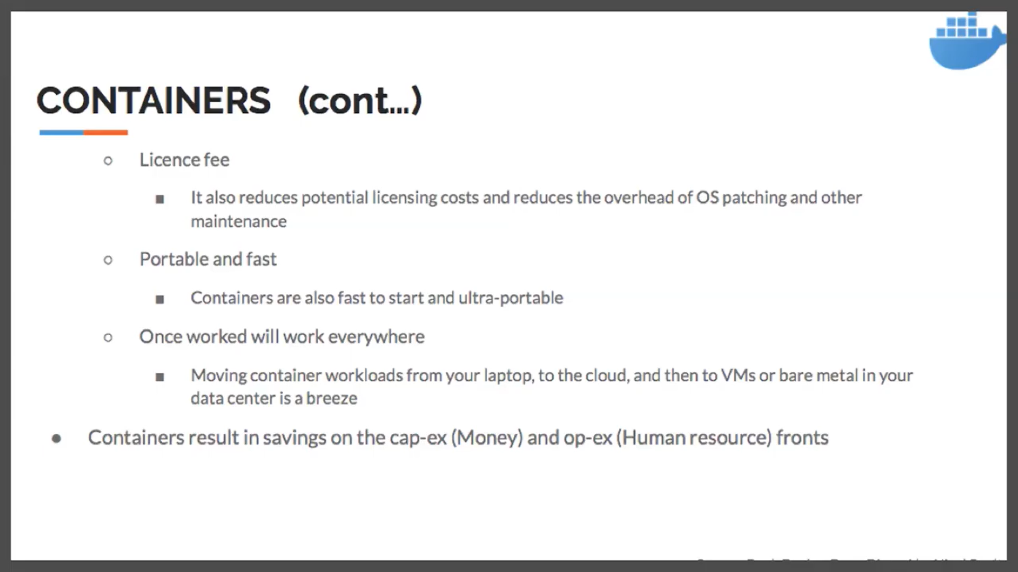

**Container Images:** These are the packages that contains relevant dependencies of a software through which that software could run on any containerized platform (system.)

**3. Types of Containers:**

* Linux Containers | Windows Containers | Mac Containers (Using Linux

Containers with VMware on Mac OS)

* 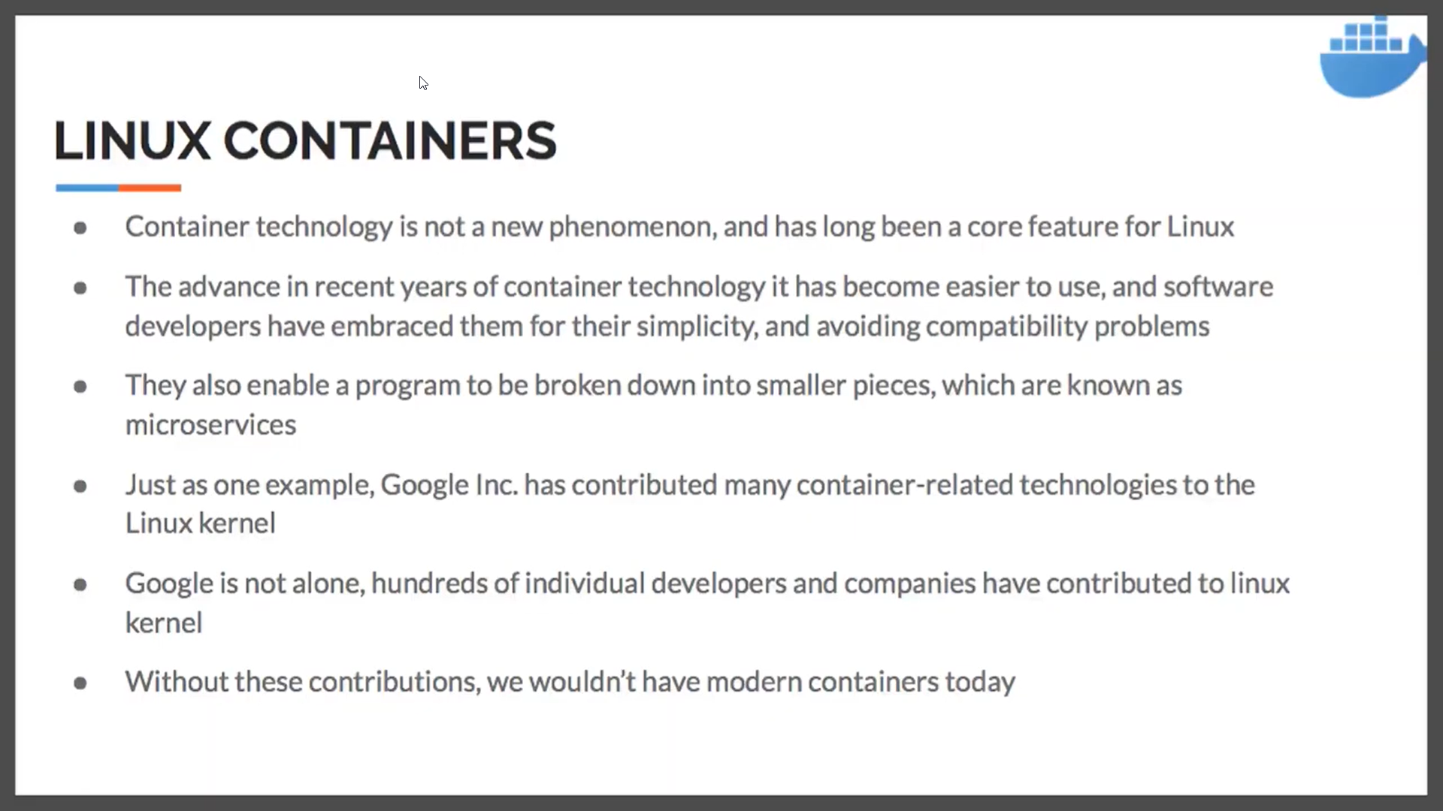
* 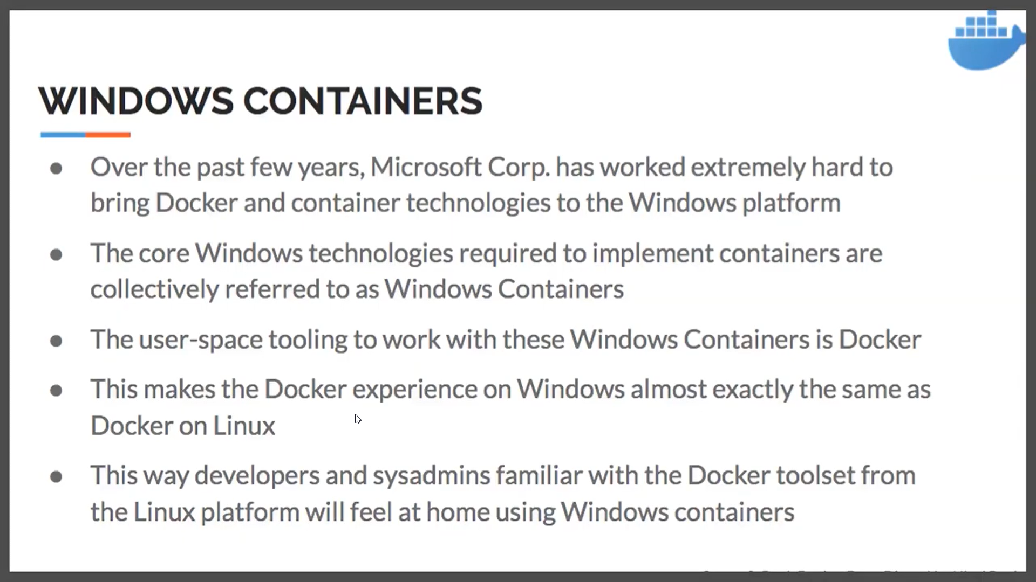
* One important point: Windows containers can only work on windows kernel (host) and not on Linux kernel. The same is true for Linux containers. But Docker provides this facility that Linux containers can run on *Docker for Windows*. However, those containers which are made on *Docker for Windows* cannot run on Linux kernel.
* 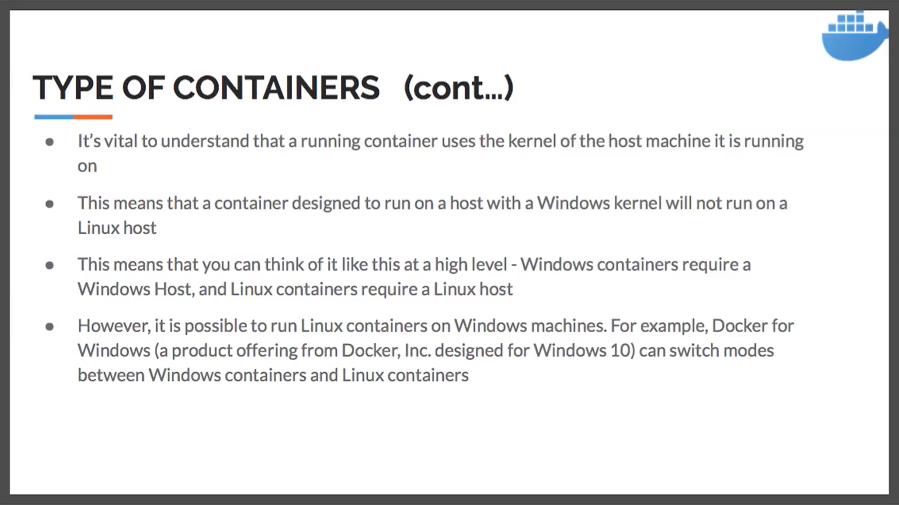

**4. Docker:**

* Docker is not a container but a container-managing software that runs on Windows and Linux which also provides us the feature of orchestration.
* Docker creates, manages and orchestrates containers.
* When we talk about Docker, we speak of the **Docker Engine**, which can be easily downloaded from the GitHub.
* Docker is available in two variants (editions): Enterprise Edition (EE) and Commercial Edition (CE).

**5. The Container Ecosystem:**

* There is a concept of Batteries which is associated with Docker. It’s a core philosophy at Docker, Inc. that those Batteries are removable.
* This means that you can swap out the native Docker features with the features of that of 3rd party. For example, the *networking stack* in Docker (which allows Docker container-to-container communication or connecting a Docker container with a non-Docker workload) can be replaced with the networking stack of the third-party.
* 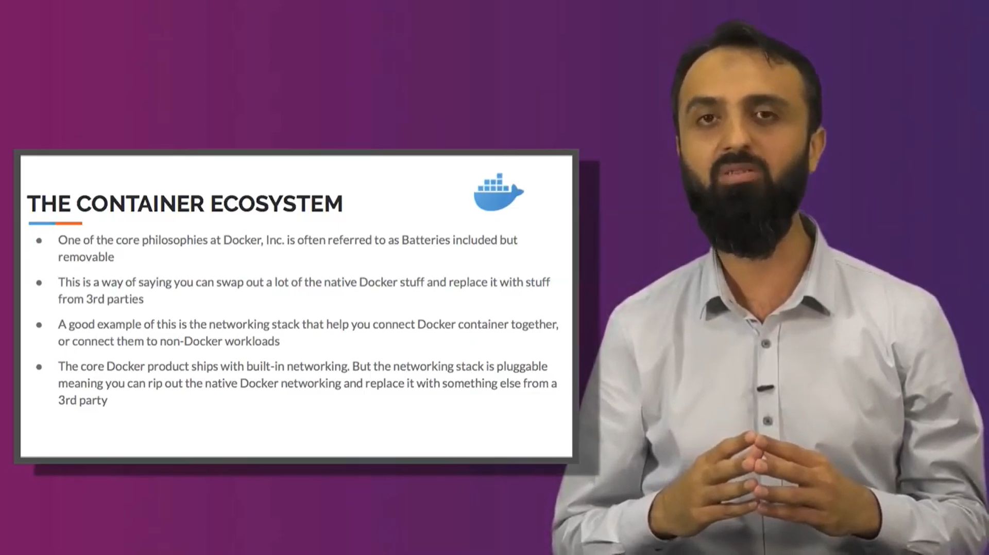

**5. The Open Container Initiative (OCI):**

* Open Container Initiative (OCI) is a governing body that with Linux Corporation set some standards related to the most fundamental components of container infrastructure: container image format (image-specs) and container runtime (runtime-specs).

**6. Docker Installation:**

* Docker Command: docker --version | *docker info*
* 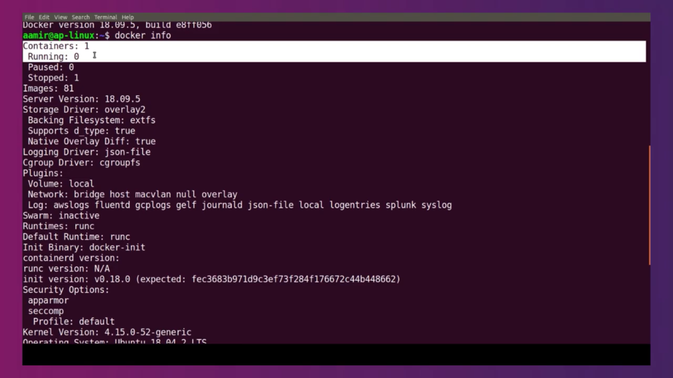
* Docker Command: docker version
* 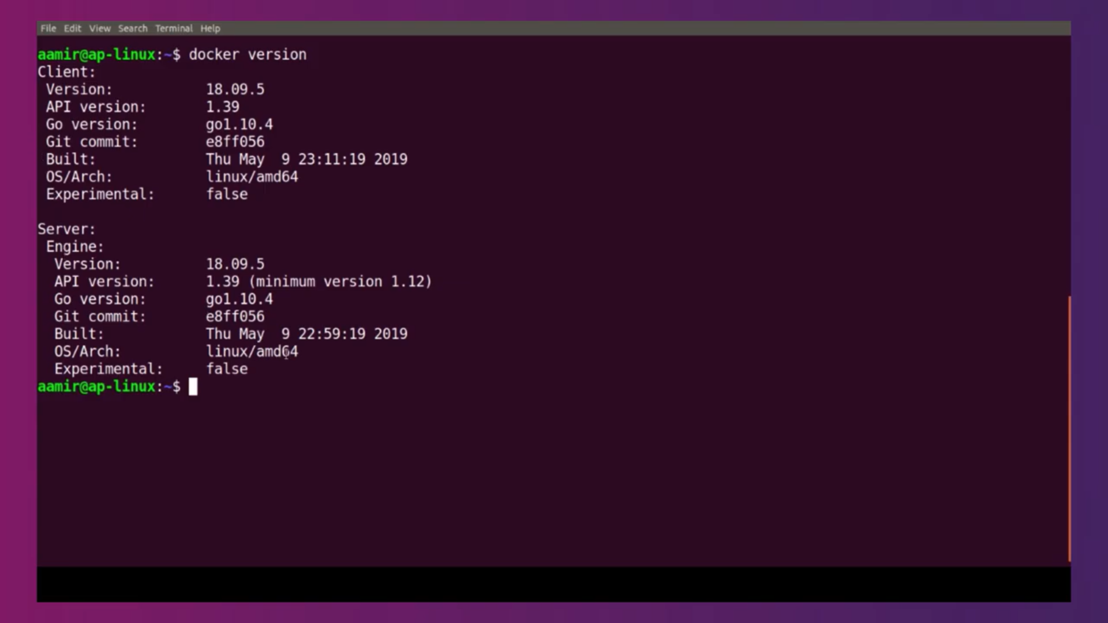

**7. Docker Engine:**

* Docker engine is the core (fundamental) software that is used to create and manage containers;
* Docker engine is known as Docker or Docker Platform;
* Docker engine architecture has modular design with swappable components (we can swap native docker components with that of the third party);
* Docker engine contains highly specialized tools (images, APIs, execution driver, runtime etc.) that work in harmony to create and run containers;
* Major Components of Docker engine: Docker client, Docker daemon, containerd, and runc. They all work together seamlessly to create and run containers.
* 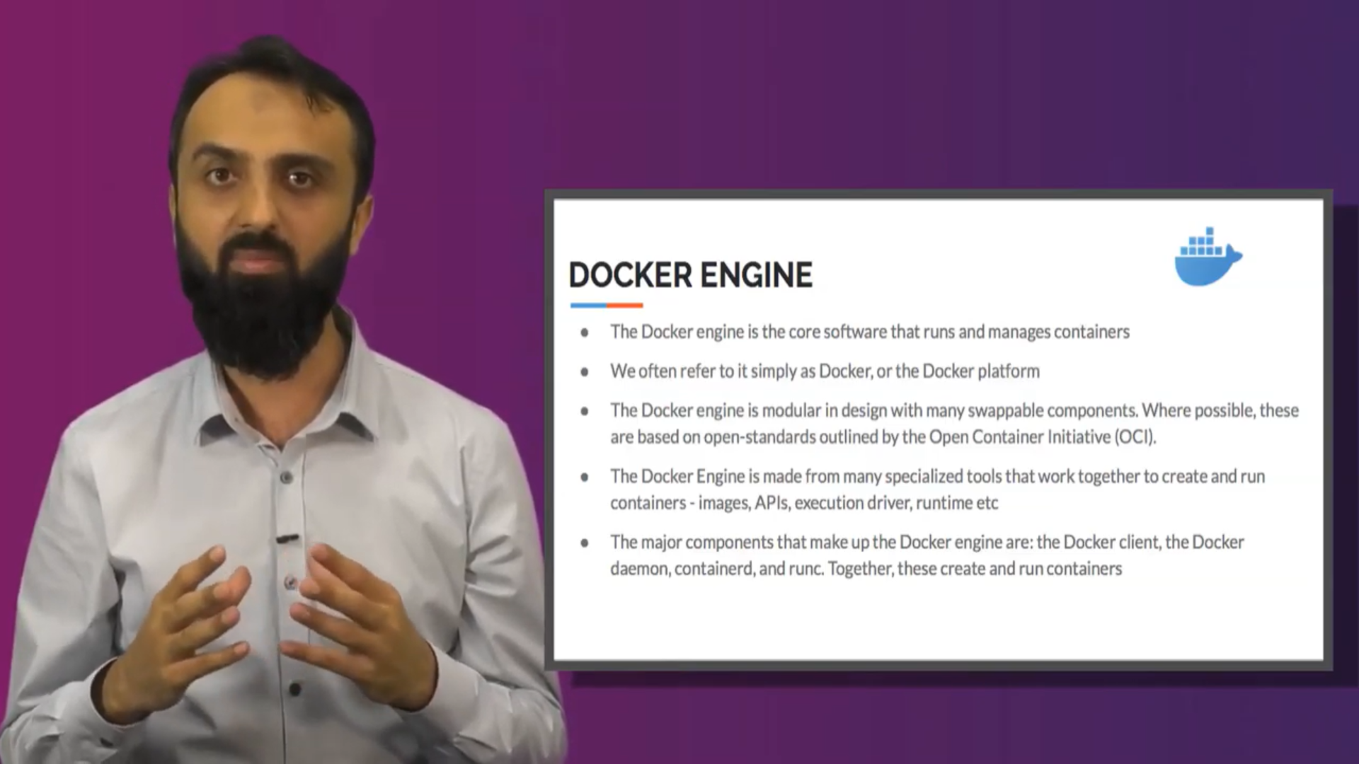
* Docker Engine Architecture: **Docker Client** is the terminal where you write your commands and interact with Docker daemon. **Docker daemon** connects with Docker API and manages Docker objects (images, containers, networks, volumes). Acting as a bridge between Docker daemon (dockerd) and runc is **containerd** which allows us to start/stop, pause/un-pause, and annihilating the containers; the only duty of **containerd** is to perform operations related to or involving container lifecycle. Then comes the **runc (runtime)** component whose sole purpose is to create containers in container lifecycle. The last is the **shim** component which is an integral component to make containers daemonless. Daemonless containers are those containers that are not attached with Docker daemon unlike in the old days, when containers were connected with Docker daemon. So, any updates in dockerd killed the containers which produced application downtime. After adding **shim**, shim provides the feature through which docker daemon could be upgraded without stopping the containers.

* 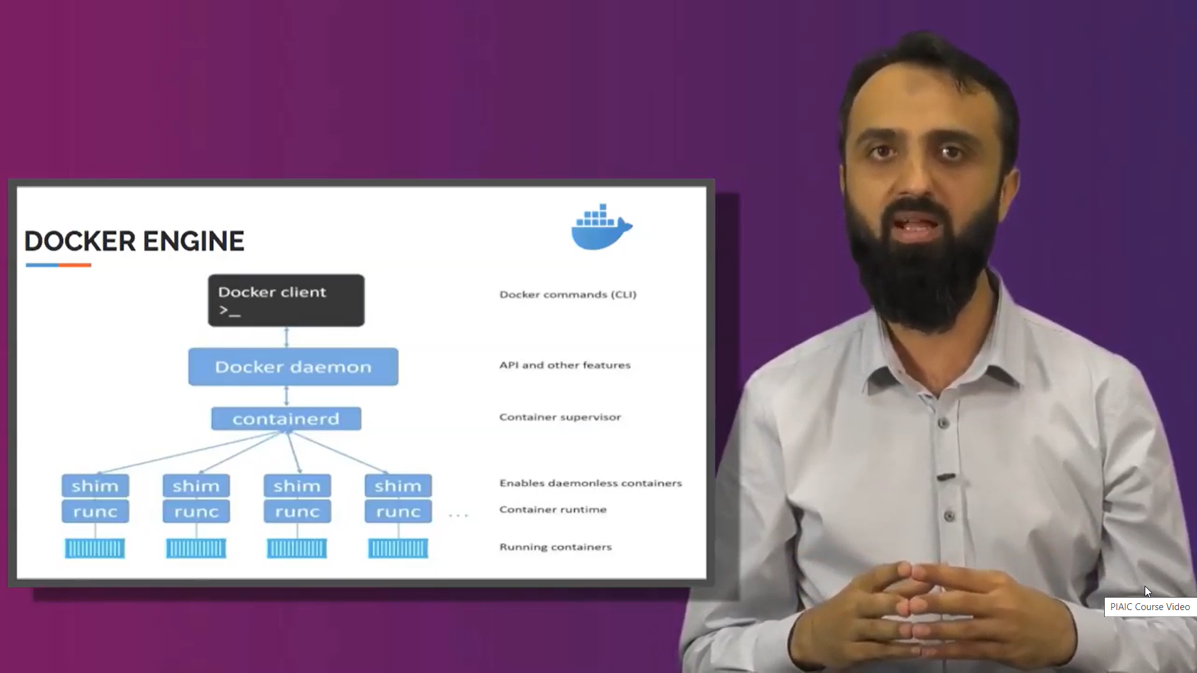
* 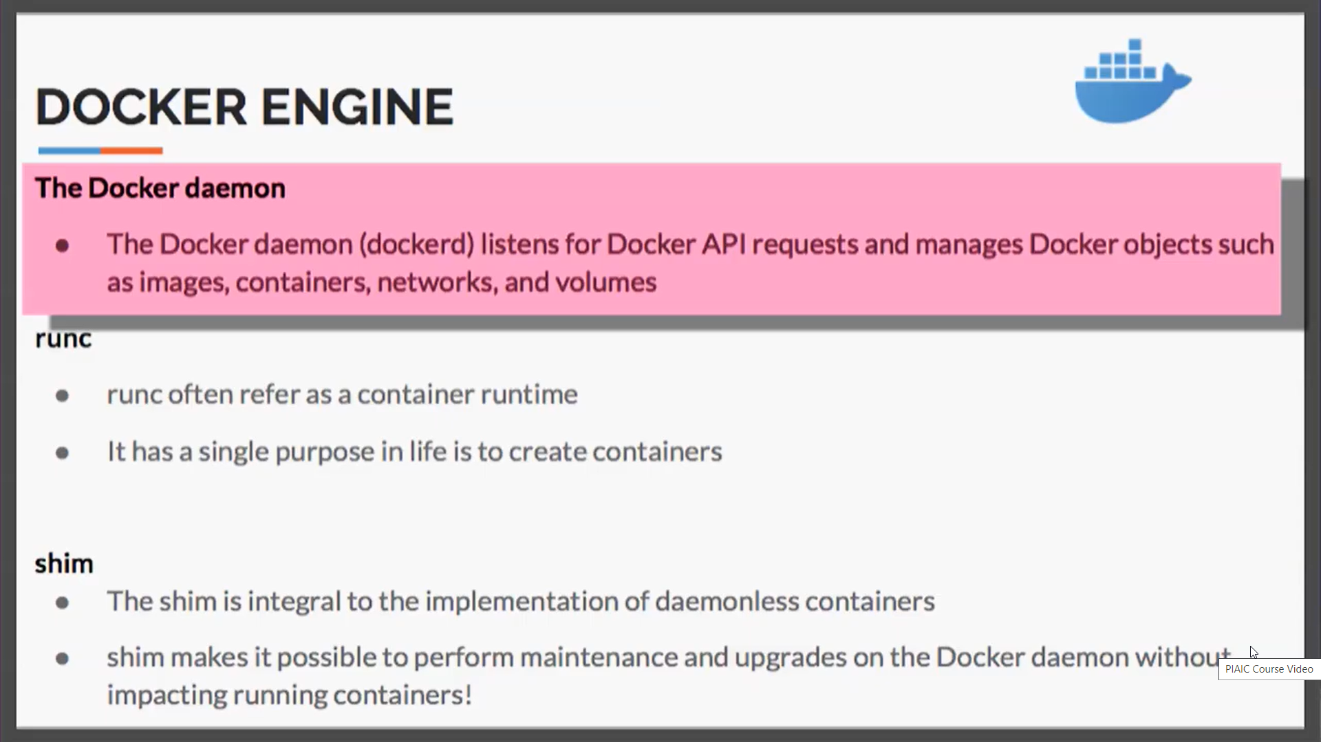
* 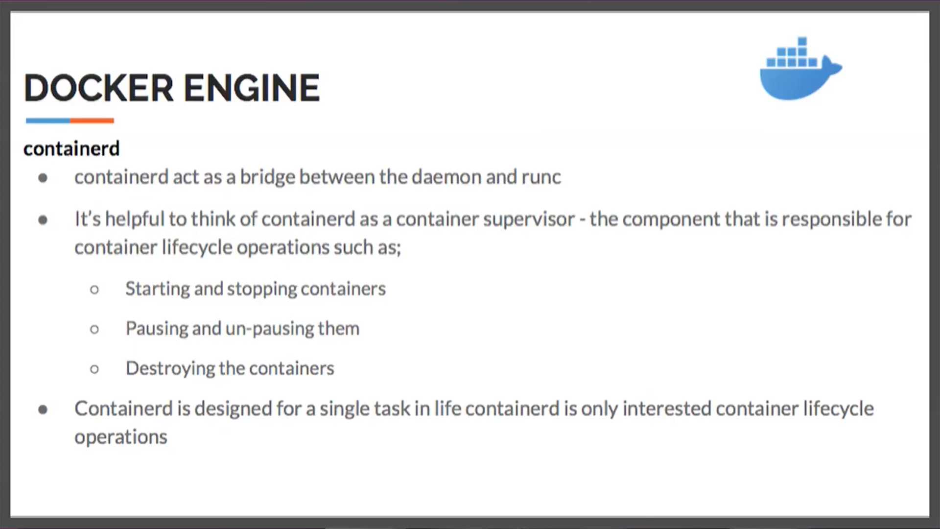

**8. Container Images:**

* 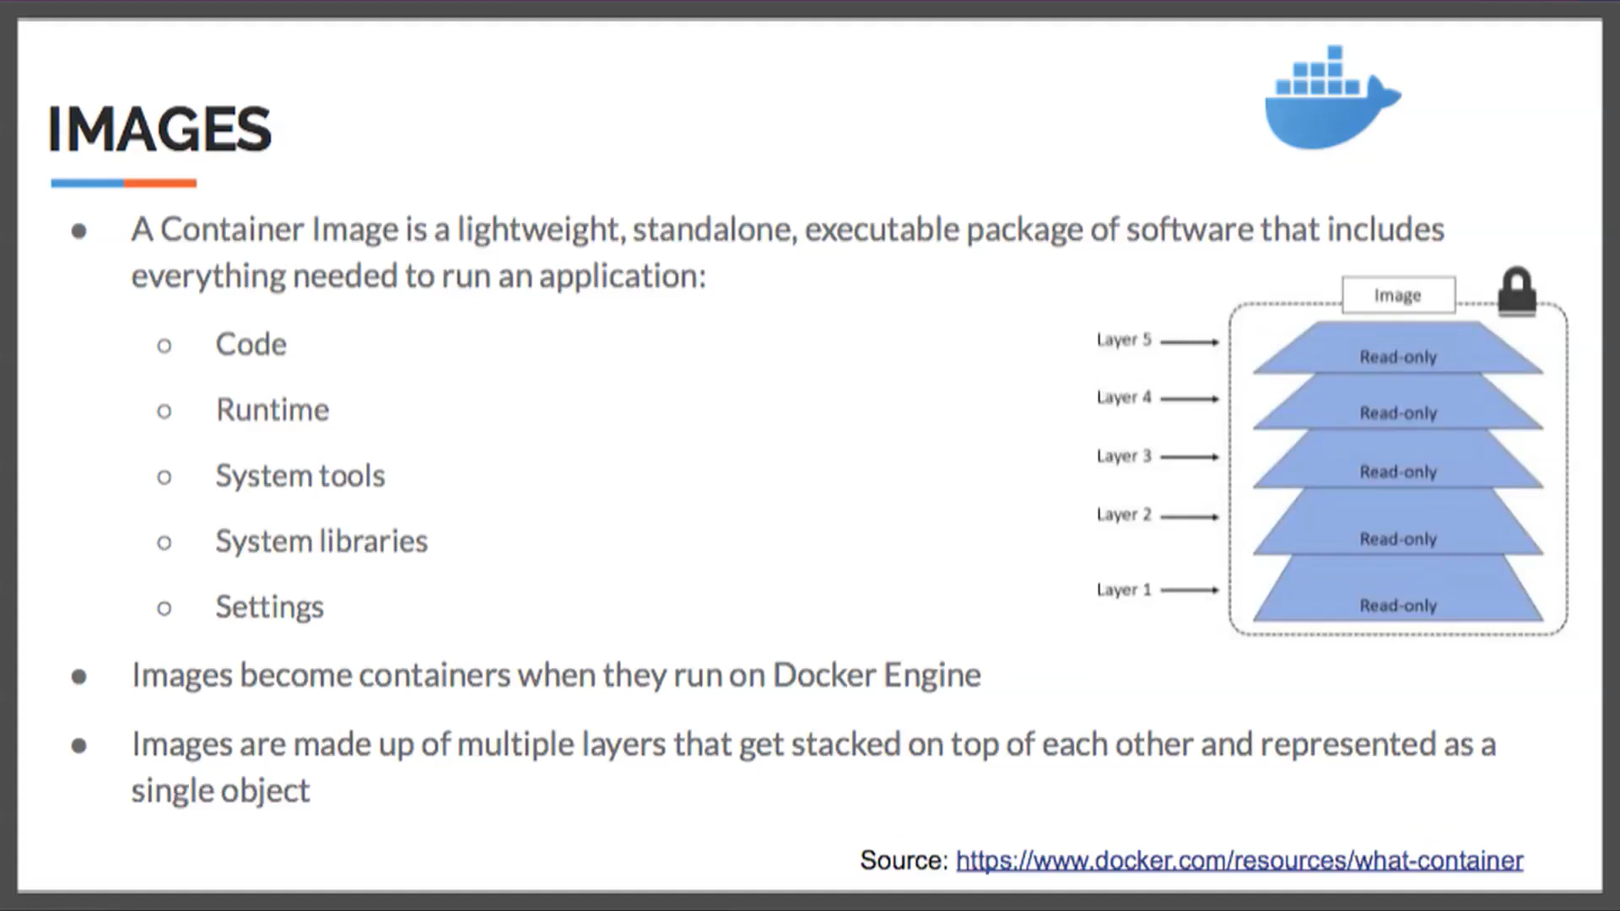
* **Container Image** 🡪 Lightweight, standalone, executable package of software which contains everything essential for running an application.
* When this *package of software*, known as **Container Image**, is run on Docker Engine, images become containers.
* Inside the image: a **cut-down OS** (OS reduced in scope or length), dependencies, and all the files required to run a containerized application.
* Container Images exist in the form of stack of layers where each layer contains different files.
* The common layers of the container images are downloaded and stored only once, and then those already-stored layers are used in running the containerized app of new images. This way, download time minimizes, and containers become portable, light weighted and fast.
* Images (aka stopped containers) ⇌ Container
* 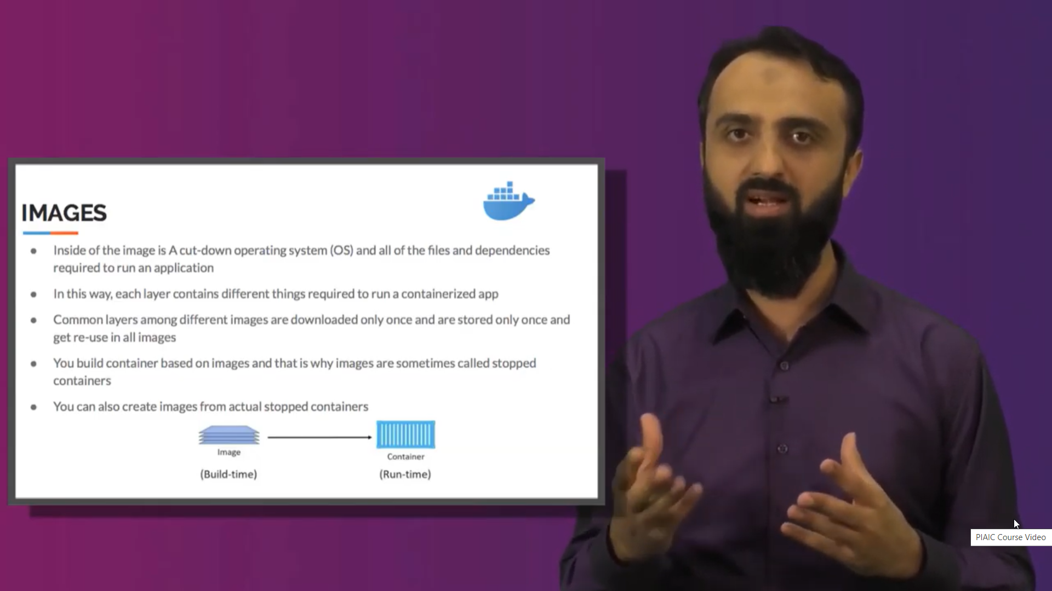
* 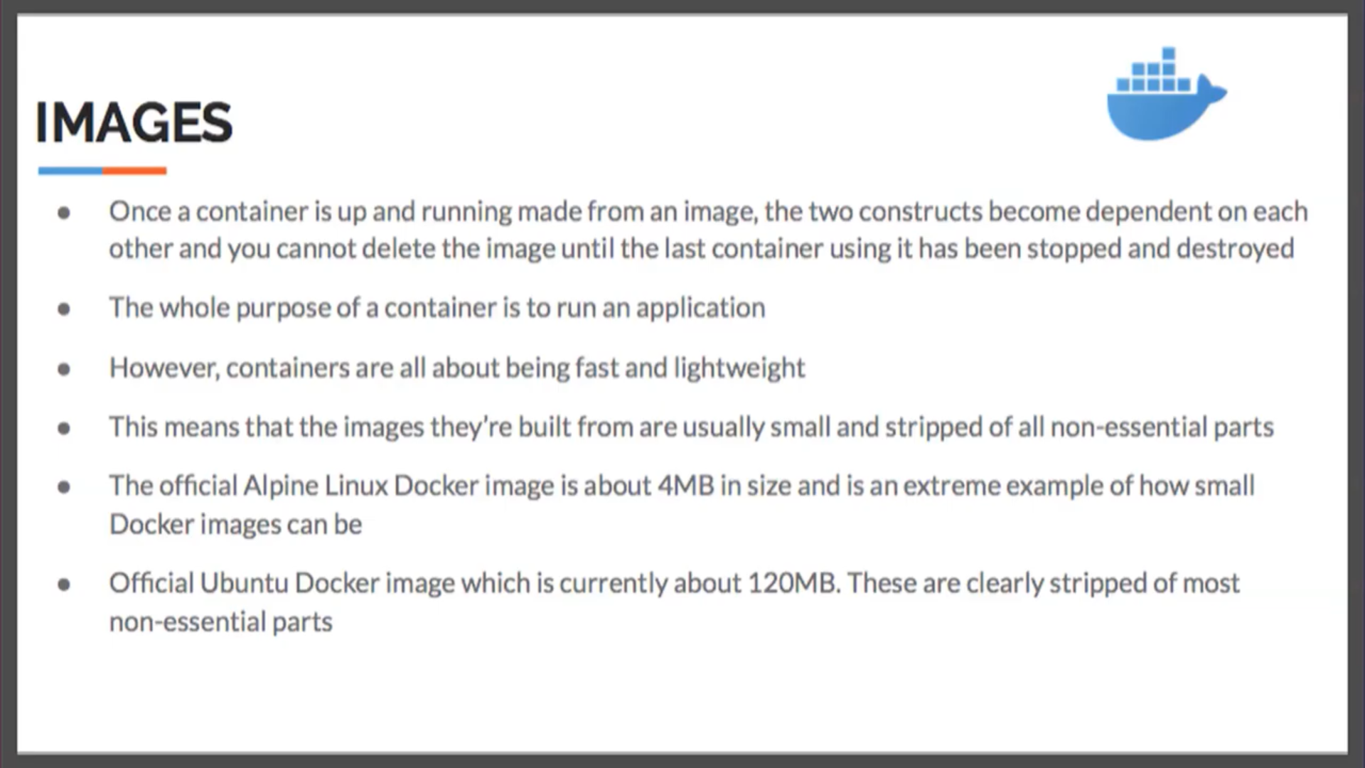
* Once a **container** has been made running from a **container image**, the container becomes **dependent** on that image. Hence, that image **cannot** be removed from the system until and unless all the related containers are **stopped** and annihilated.
* The **sole purpose** of a container is to run an application.
* Since the containers are all about being fast and lightweight, the images that they are built from also has to be small and cut-downed (only most-required files).
* Alpine Linux (Linux OS) Docker Image 🡪 4 MB
* Ubuntu (Linux OS) Docker Image 🡪 120 MB
* Those Linux OS executable files are heavy in actuality, but their docker images are small and lightweight which shows how much their non-essential elements (gui for example which is not needed for running containers) are cut-downed so that it contains only those files which are extremely required to run a containerized app.

**9. Image Registries:**

* Docker Images are highly portable meaning that they can be stored on any server (registry).
* Container Images are therefore stored on image registries, commonly on **Docker Hub** (an image registry).
* The default registry of Docker Engine is also Docker Hub. So, when a container image is being uploaded on the web registry, the engine uses the server of Docker Hub.
* On Docker Hub, the images are stored in image repositories, whereby each image repository contains different versions of an image (picture below).
* Analogy of Docker Hub:
  + Image Registry 🡪 Room | “Docker Hub”: name of the room;
  + Image Repositories 🡪 File Cabinets | Images as files.
* The Image Registry on Docker Hub are of two types: Official Registry and Unofficial Registry.
* **Official Registry** is where the container images of large companies are stored that are closely examined and monitored.
* 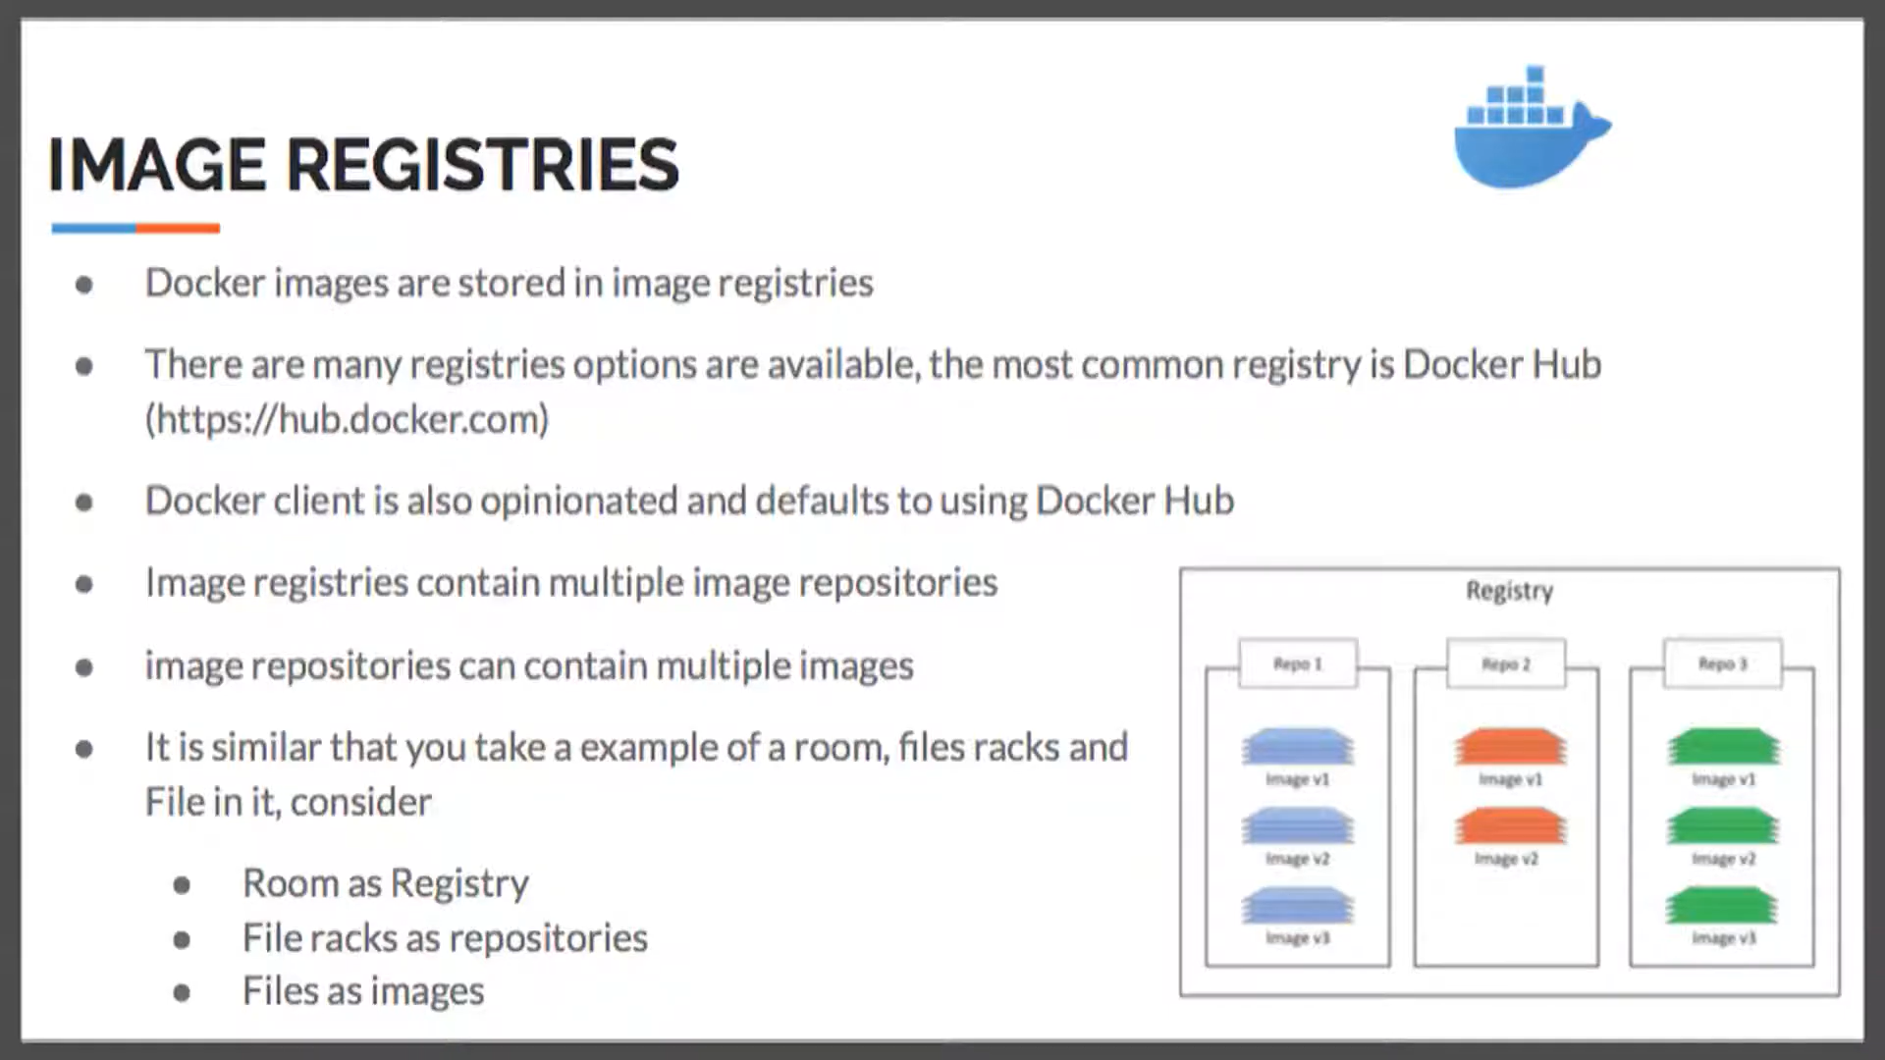
* 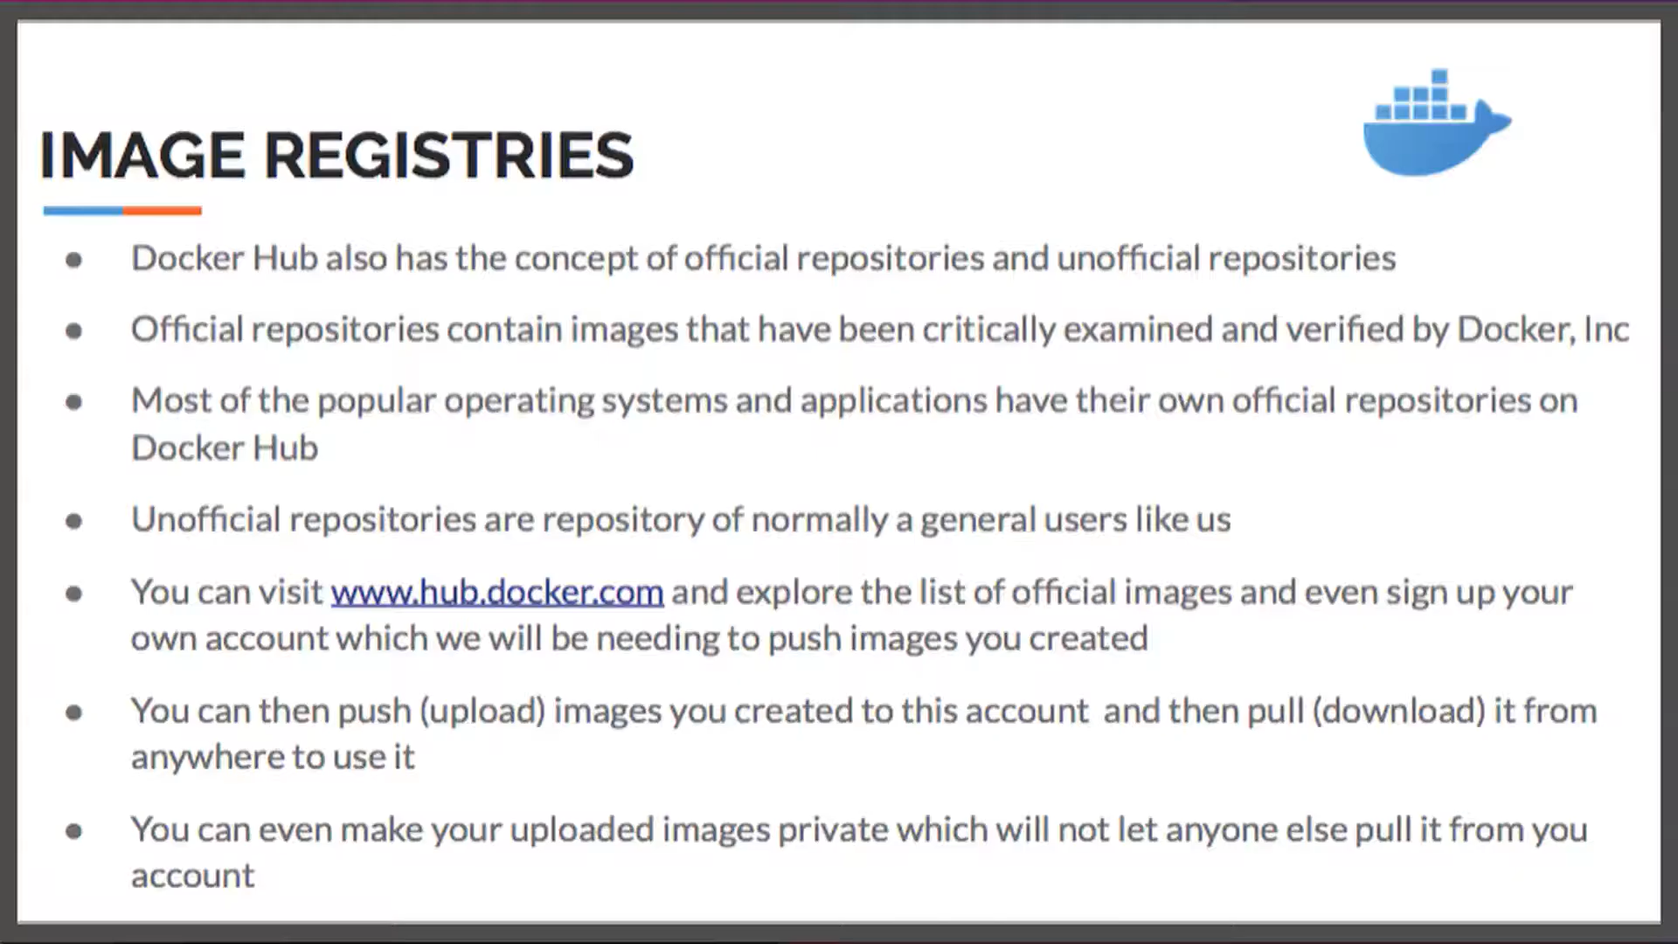
* **Unofficial Registry** on Docker Hub is for general users so that anyone can push (upload) uncountable number of images on the image registry, and then later pull (download) them from the Docker Hub, build a container based on it and run their containerized application.

**10. Image Naming and Tagging:**

* Pulling (Downloading) a docker image from **Official Repository** of Docker Hub (example: pulling Ubuntu official image):
  + **Command:** docker image pull <repo name>:<tag>
* Pulling (Downloading) a docker image from Unofficial Repository of Docker Hub:
  + **Command:** docker image pull <username>/<repo name>:<tag>
* 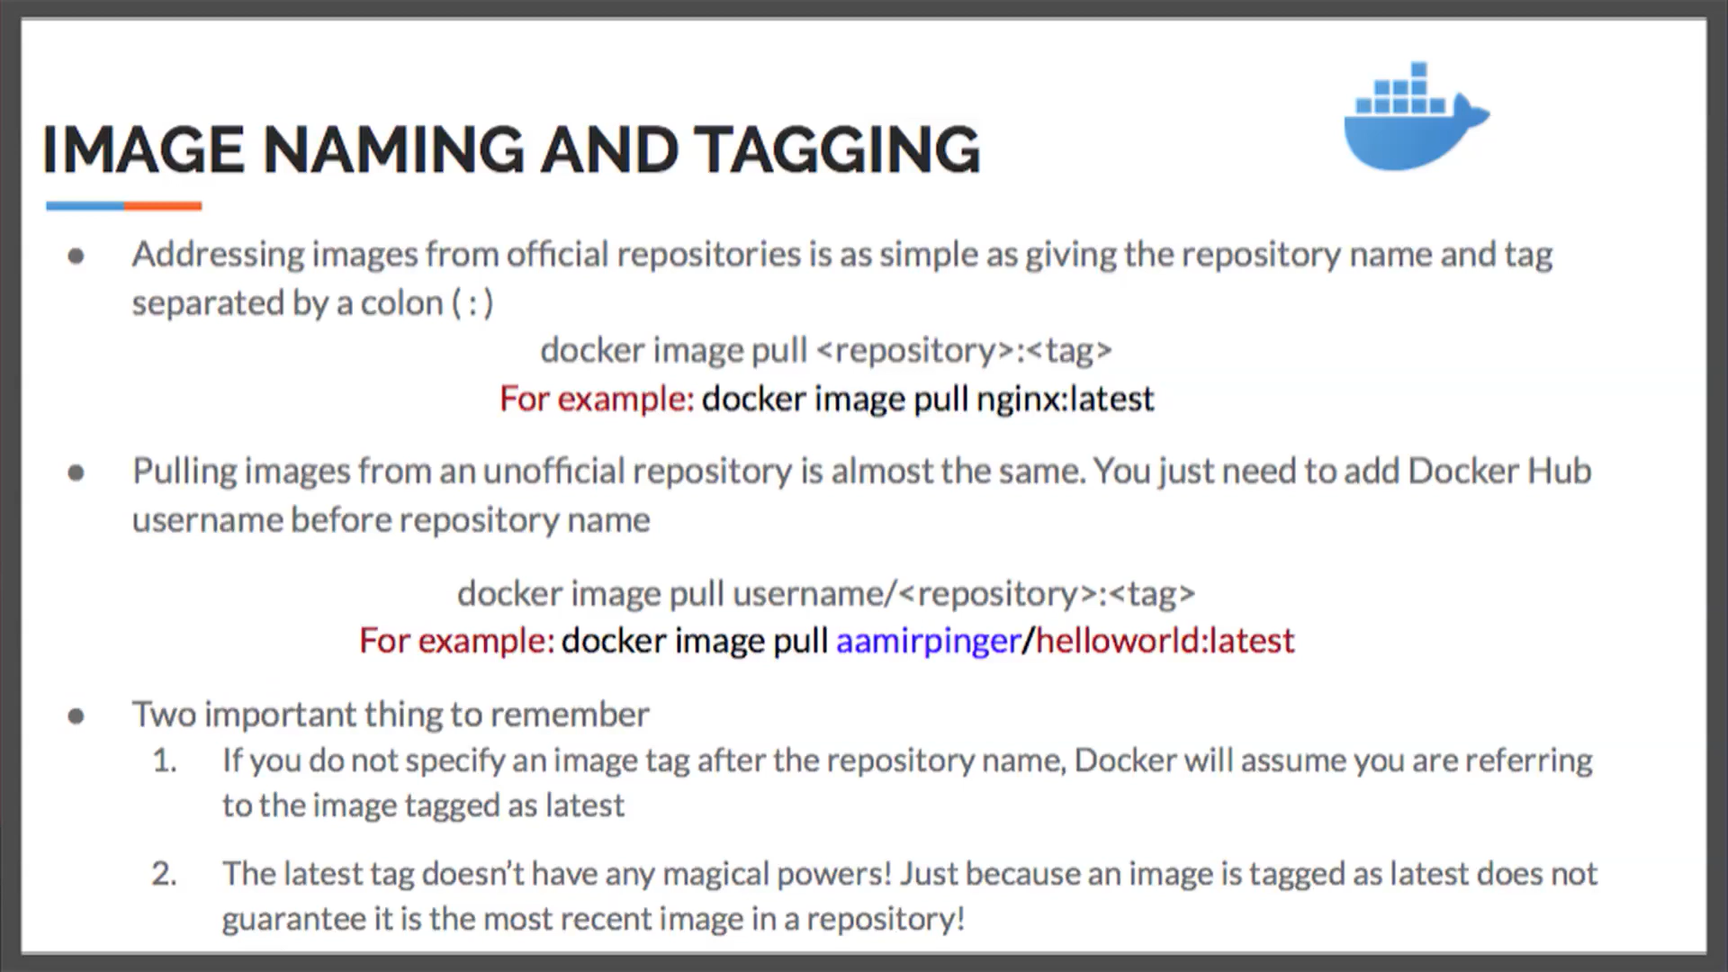

**IN THE CODE:**

**Docker Image Pull = Docker Pull** (Because images are what present in Docker Hub)**.**

**If tag not provided, Docker puts** latest **by default.**

* 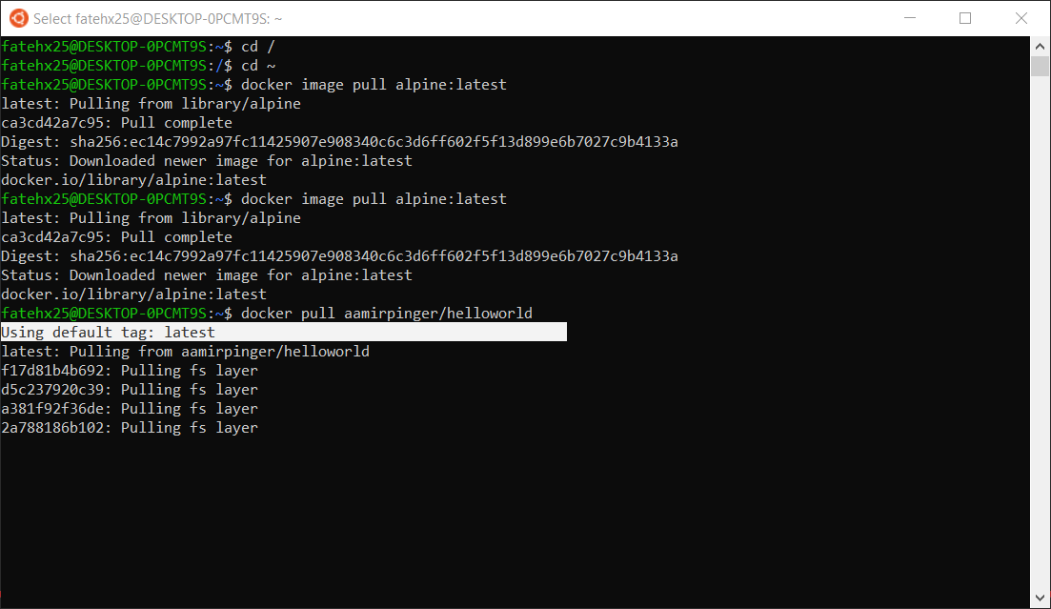

**11. Image Listing:**

* To view images pulled on the system:
  + **Command:** docker image ls (ls means list); or
  + **Command:** docker images
* 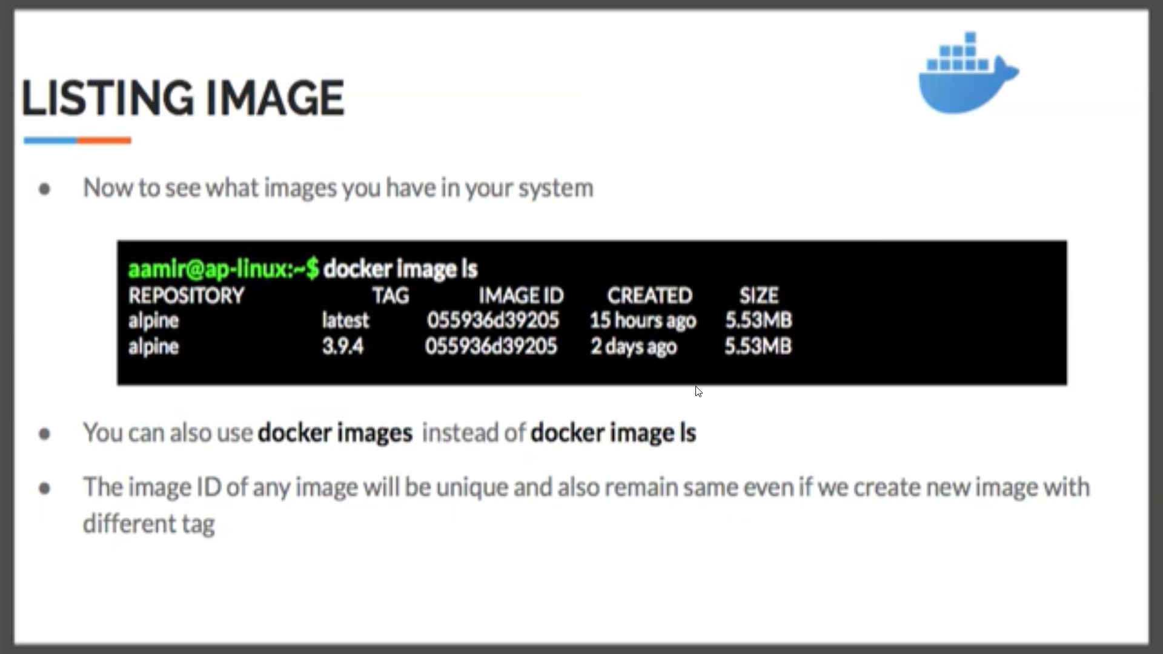

**12. Removing Image:**

* For removing an image,
  + **Command:** docker image rm <repo name>:<tag>
* 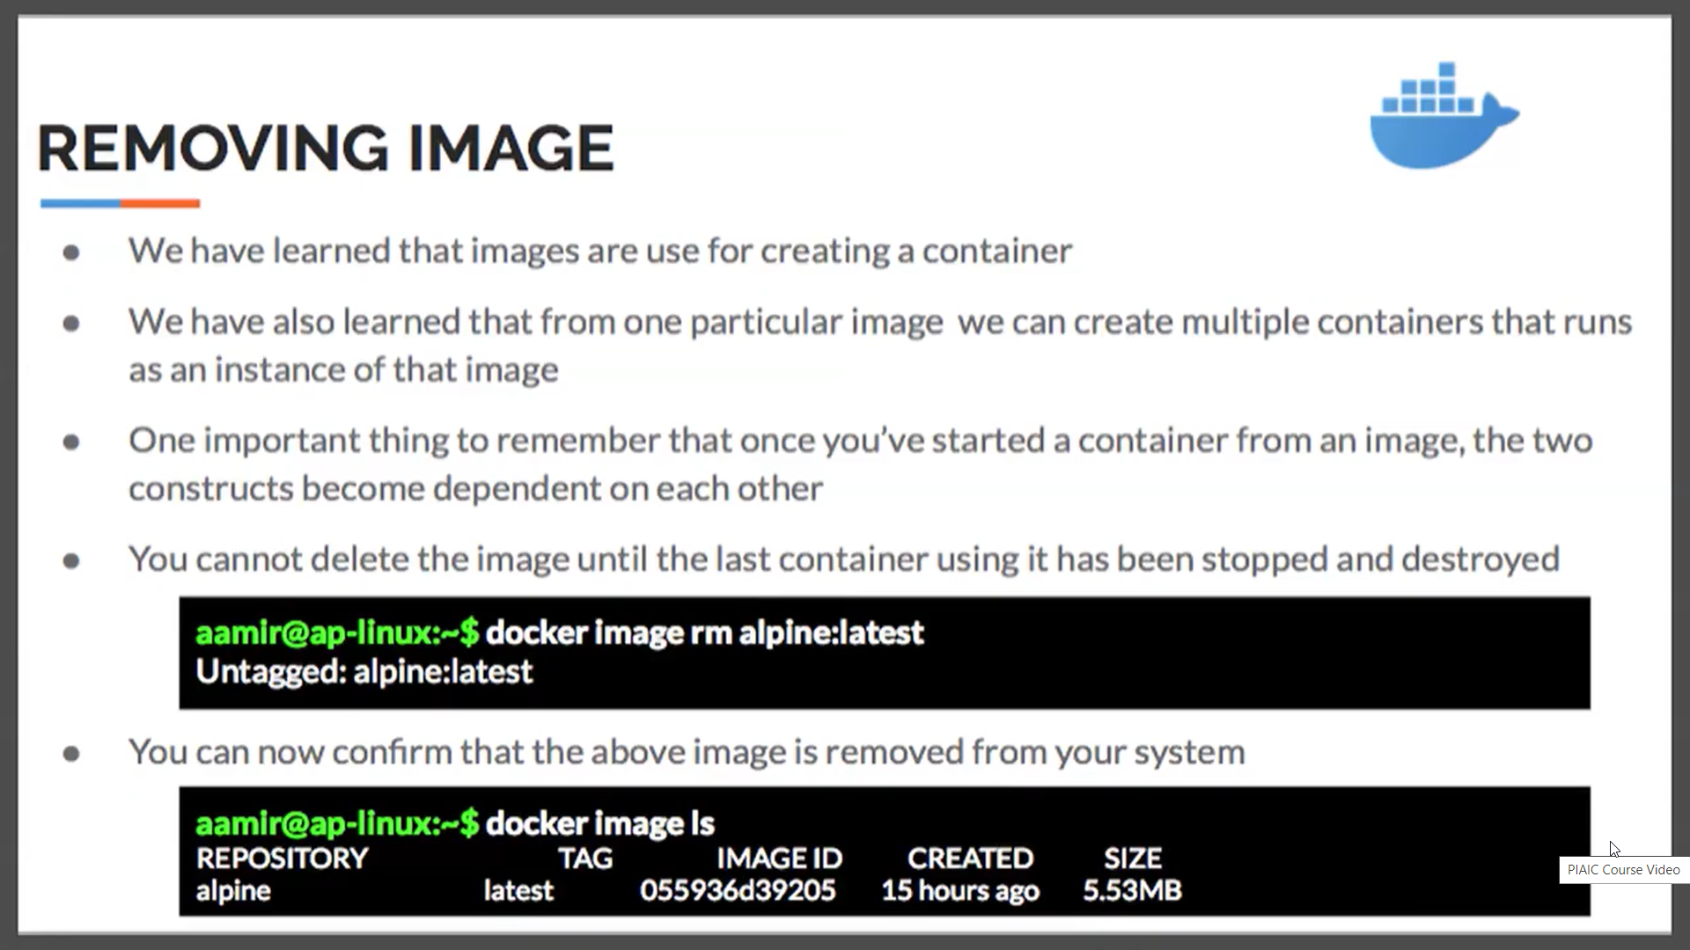

**13. Running a Container:**

* A container is a **run-time instance** of an image;
* Just like **VM template** is used for staring the **Virtual Machine**, a **Container Image** is used to start one or more than one **Container**.
* Multiple applications can be started using a single image.
* Containers are way faster than VMs because they run on images having **cut-down OS**. In other words, containers **share** the OS/kernel with the **host** (server) they are running on.
* 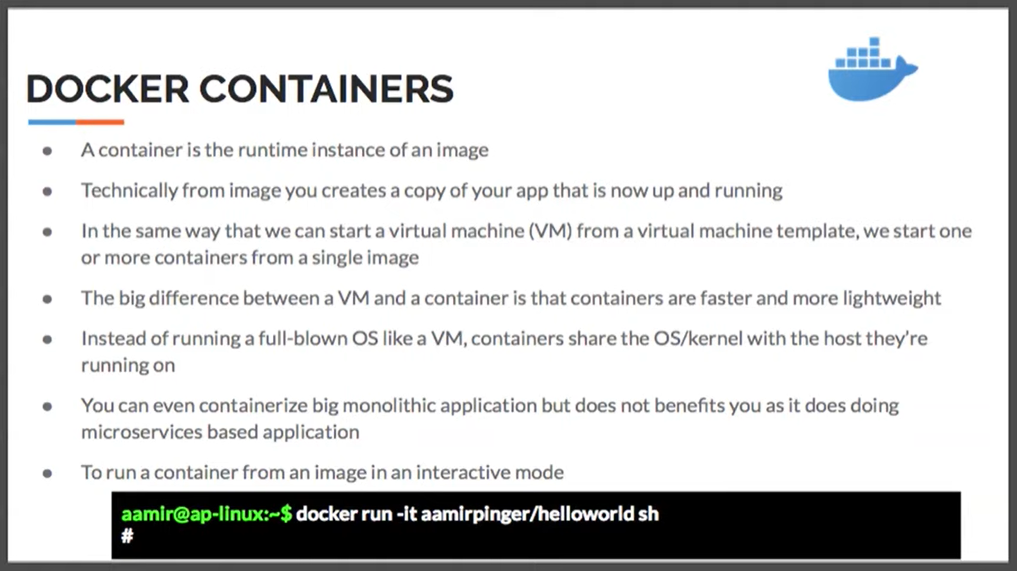
* For starting a container from an image,
  + **Command:** docker run -it <username>/<repo name> sh
  + runcommand**:** starts or runs the container; { کو چلاو application یعنی ‘run’}
  + **-it** command**:** starts container in an ***interactive*** mode;
  + We need to state which medium to use to interact with containerized app filesystem 🡪 sh / bash 🡪 shell.
  + **sh : tool for interaction.**
  + When you see #, it means that the terminal has now taken us to the shell of our **containerized app filesystem**.
* For listing the **running containers**,
  + **Command:** docker container ls; or
  + **Command:** docker ps For info on 🡪 [ps](https://docs.docker.com/engine/reference/commandline/ps/)
  + The command might not show anything because when we were directed into the containerized app filesystem via an interactive mode, we applied the command exit and docker engine interprets it as a command for **stopping** the container.
* For listing the containers [**in any state**],
  + **Command:** docker container ls -a; or
  + **Command:** docker ps -a
  + -a or --all flag stands for **all**.
* **Docker Engine** understands the containers and images both from its **name** (example: aamirpinger/helloworld) and **id** (example: 87a90e5331cb).
* To exit the containerized app filesystem w/o stopping the container,
  + **Command:** (On keyboard) 🡪 **Ctrl** + **P** + **Q**
* To re-enter into the interactive mode of a running container application filesystem after exiting it through keyboard,
  + **Command:** docker exec -it <container name or container id> sh
  + **exec** (re-entering in an already-running container)stands for ***execute*** which is different from **run** (starting a new container from an image).
  + Now, the command **exit** would not stop the container.

**14. Stopping Container:**

* **Command:** docker container stop <container name or container id>
* After the command has run successfully, the terminal will return the entered <container name or container id>.

**15. Starting Container:**

* To start a stopped container,
  + **Command:** docker container start <container name or container id>
  + After the command has run successfully, the terminal will return the entered <container name or container id>.

**16. Removing Container:**

* If you try to remove a running container, the docker engine (docker daemon) gives an error stating that the container should be stopped before removing or to be force remove. 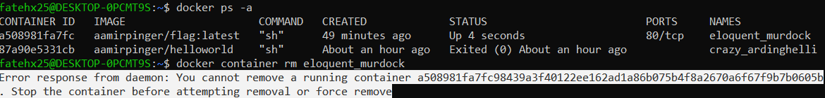
* Command: docker container rm <container name or container id>
* Removing a container would also remove any data stored in the filesystem of that container, which is irreversible.

**17. Container in Detached Mode:**

* An alternative way to start a container, but instead of interacting with it, if we’d like to run the container in background,
  + **Command:** docker container run -d <username>/<repo name> | returns **cont_id**…random no.
  + **-d**: Stands for **detached** mode; No need for **sh 🡪 Not interactive**

**18. Publishing Port:**

* Since the newly started (**Interactive**/**detached**) **container** is a **web-based** containerized application, an **accessibility point** has to be created so that the containerized app can become accessible to the **public** through **web servers**.
* If more than one containerized **application** is present on a **server** or computer, that server could be accessed through its **local IP address**. But, how would the **docker engine** know which application to access on the same server? Here comes the concept of **Port**.
* **Analogy:** If an area is a *System’s IP Address* then the shops with that area would be *Ports* *of Containerized Apps* which are differentiated through ***Port Numbers***just like shop numbers make each shop unique in that area.
* **Command:** docker container run -d -p <Port Number>:<Internal Port Number> <image name>
* **<image name>** has to come in the last.
* **-p** flag is used for **publishing** the containerized application.
* **<Port Number>:<Internal Port Number>** so that after user reaches our system through IP address, it is further directed to a **Port** through **<Port Number>** which is directly connected to an **internal port (within container)** via **<Internal Portal Number>** from which our containerized app is accessed. 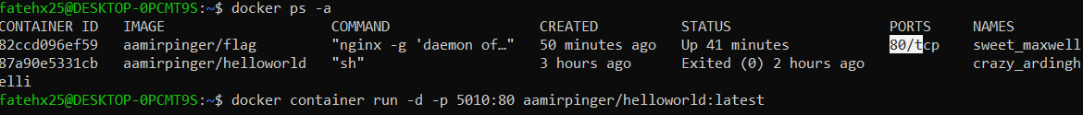
* After publishing the containerized app on the port ‘5010’ which is virtually connected to an internal port ‘80’, the containerized app would be running if you go into your browser and surf: “**localhost:5010**”.

**19. Custom Container Naming:**

* You can give your custom name to the new container through the following:
  + **Command**: docker container run -d --name=<container name> -p <Port Number>:<Internal Port Number> <image name>; or
  + **Command**: docker container run -d --name <container name> -p <Port Number>:<Internal Port Number> <image name>.
* Publishing above containerized application on Port “5020:80” can be accessed through the address: “localhost:5020”, where *Localhost* gives the System’s IP Address.

**20. Containerizing an App:**

* **Containerization** / Dockerization: Building a containerized application from an image.
* The process of containerizing an app – from the making of an image till the running of container(s) based on that image:
  + Start with **application code**;
  + Create a **Dockerfile** – describing the app, its dependencies, and how to run it;
  + Provide that Dockerfile as an input to **docker image build** command which creates an image out of a Dockerfile;
  + Run a **container** from that newly created image.
* 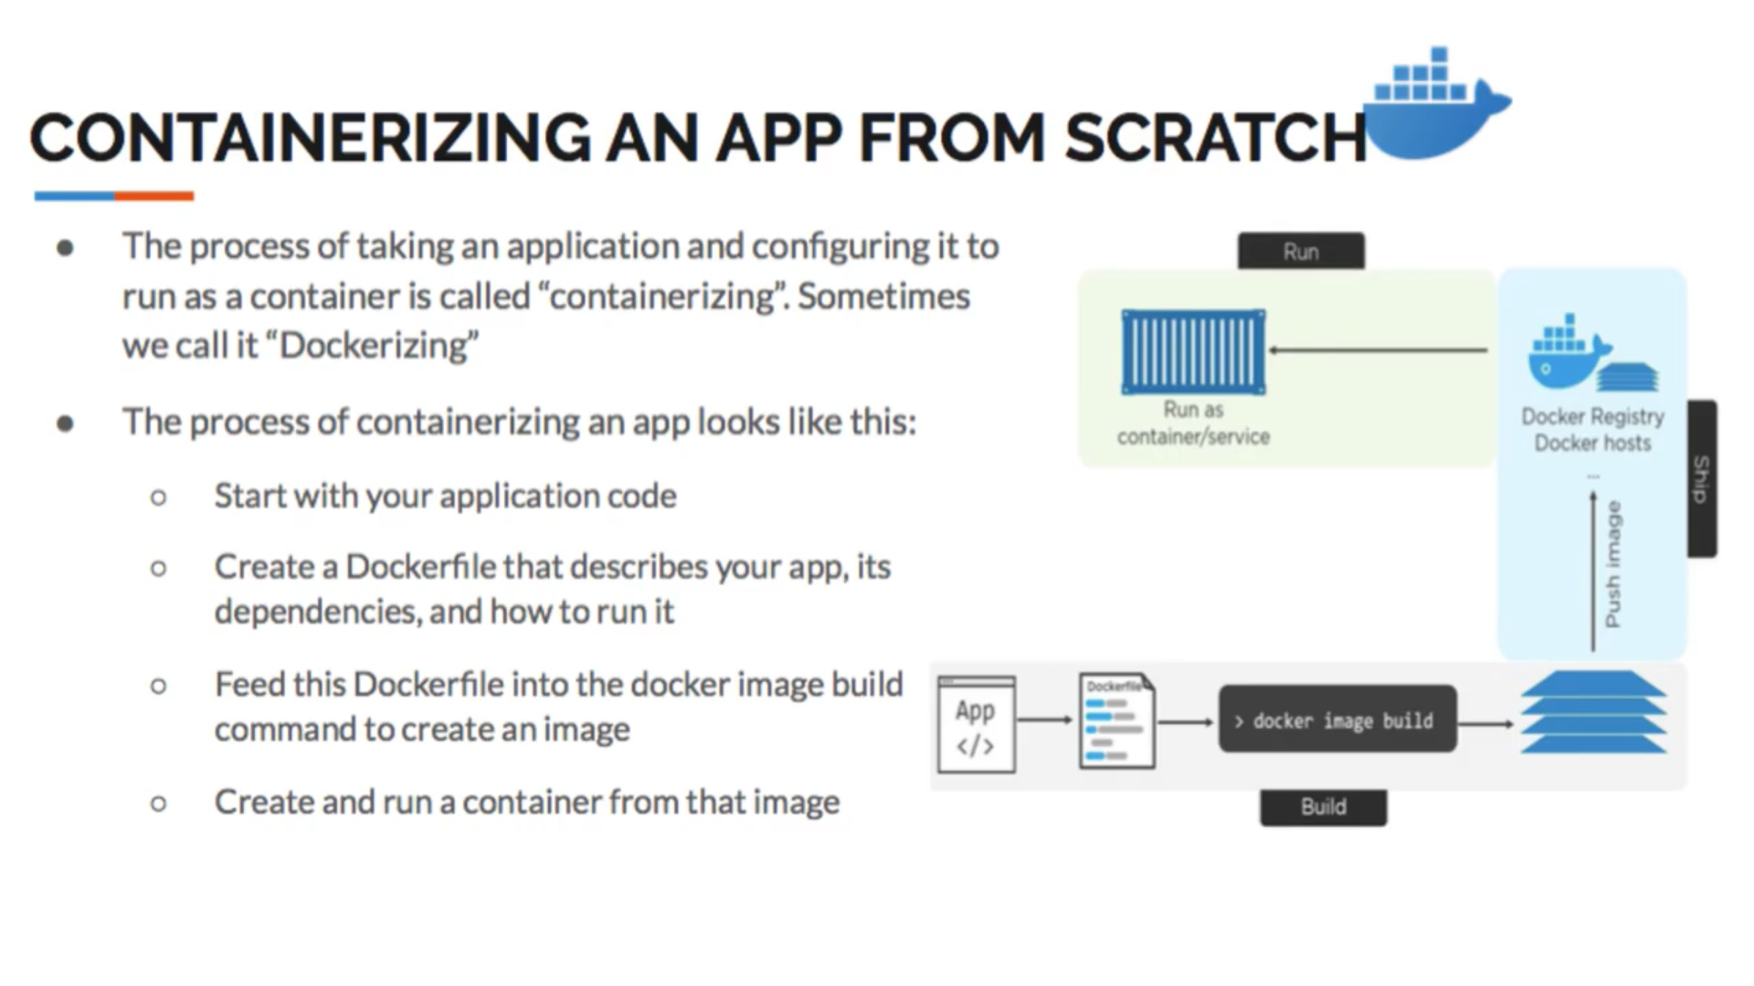

**21. What and How about Dockerfile:**

* Dockerfile is a simple **text file** which defines the application, its dependencies and how to run it.
* 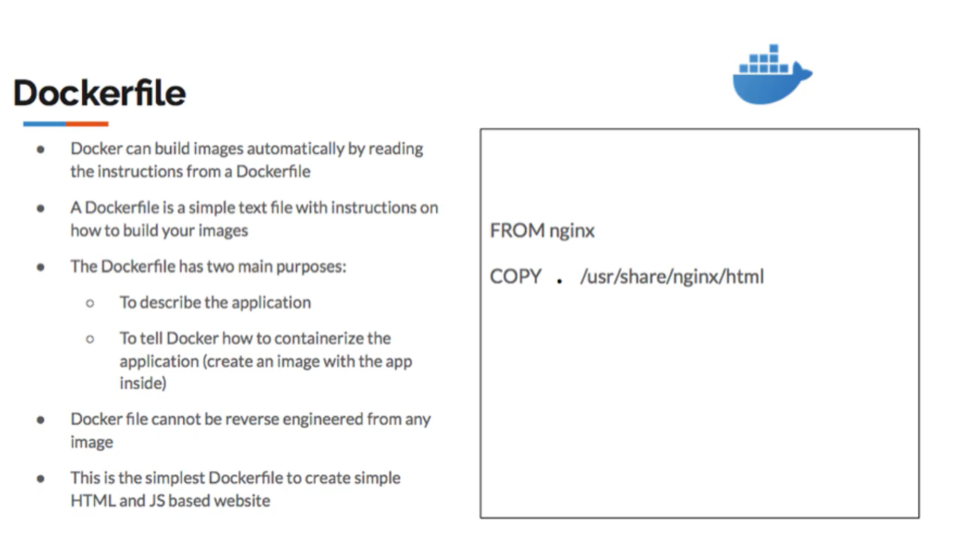

**On top right** is a simple dockerfile of two lines. Since the application to containerize is a simple webpage which requires nginx to run, the first line of the dockerfile commands Docker to download nginx image. Since nginx requires that all the relevant files shall be on a particular path, the second line of the docker file commands docker to copy all the files in the current location (the filesystem where we are, going to give docker image build command) to the given path of nginx.

* **Dockerfile** describes the application and commands Docker how to containerize the app (Create image with app inside).

**22. Dockerfile (Complex):**

* 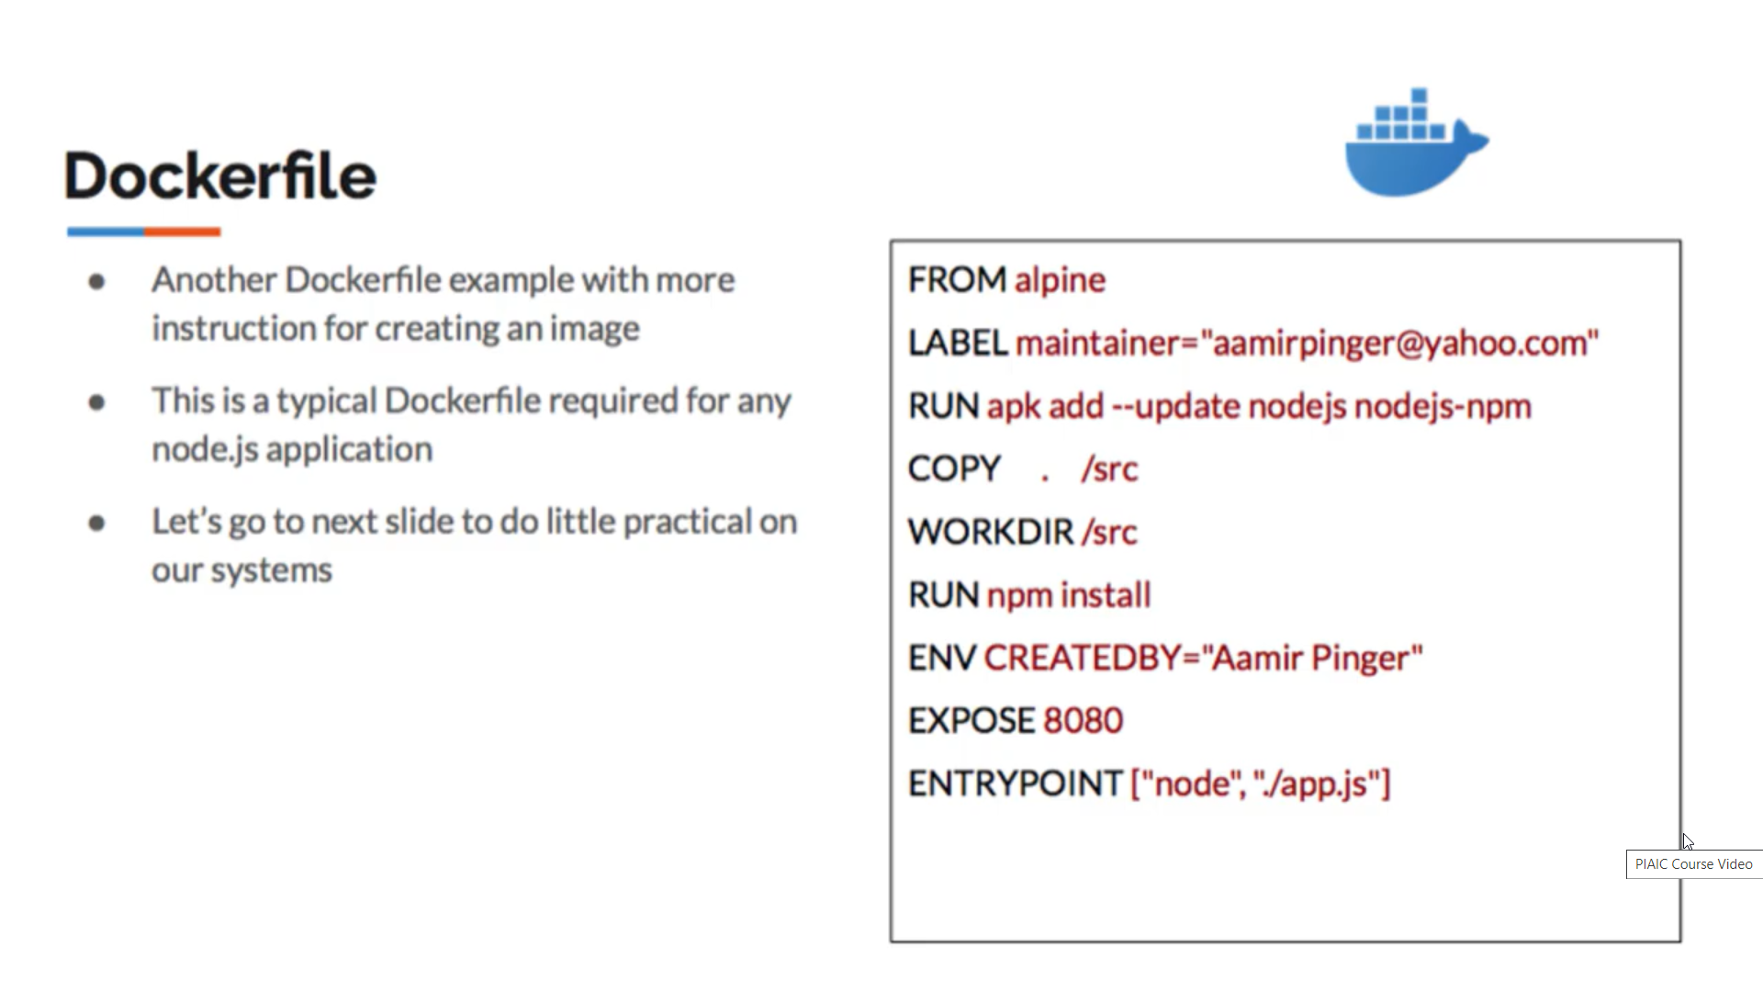
* The dockerfile on the top right is a more complex dockerfile which is of an application that is based on node.js, which is independent of nginx.
* 1st Command (**FROM**): Download the image of basic linux OS: Alpine.
* 2nd Command (**LABEL**): These provides tags which gives information about the maintainer/creator of the image so that he/she could be contacted.
* 3rd Command (**RUN**): The run command installs nodejs and npm modules in the containerized application filesystem (container filesystem). Hence, we’d have to state which modules, libraries, or runtimes to install for the code to work.
* 4th Command (**COPY**): All the files in **our** filesystem will be copied to the specified path.
* 5th Command (**WORKDIR**): This command makes the specified directory the current working directory which makes it default that the new commands shall be run into the new specified directory (working directory). When the containerized application would be building, the docker daemon (docker engine) would automatically run the next command(s) in the specified working directory.
* 6th Command (**RUN**): The docker engine implements the installation of npm package while creating the image.
* 7th Command (**ENV**): Providing environment variable and value is passed on when the containerized application runs and the value can be accessible to the application for any purpose.
* 8th Command (**EXPOSE**): This command defines the internal port number on which the containerized application will be accessible.
* 9th Command (**ENTRYPOINT**): To run a nodejs application, the command is ‘node <app.js (nodejs app name)>’. The ENTRYPOINT stores this information which is used to run the nodejs application.

**23. Containerizing an App (Practical Example 1):**

* The link for the first docker application is: <https://github.com/aamirpinger/docker-slide-code>
* The repository on the above link contains the docker application files. So, open your Linux terminal and clone the above repository using the following code:

git clone https://github.com/aamirpinger/docker-slide-code.git

* After that, with the command of ls, you could see the only directory pulled. With the command cd docker-slide-code, hop into the directory. There you’ll find the two main folders: html-js-app and node-js-app. Go into any one of the folders and follow the readme file in that folder.
* To view a dockerfile,
  + **Command:** cat <dockerfile name>.
* If you are in html-js-app, for example, you can containerize this app by the following command:

docker build -t first-docker-app . {Creating Image: you give dockerfile to the docker engine which creates an image using the ‘build’ command};

docker container run -d -name=first-docker-cont -p 8500:80 first-docker-app {Running Container}.

* Now, jump onto the following address in your browser: [http://localhost:8500](http://localhost:8500/).

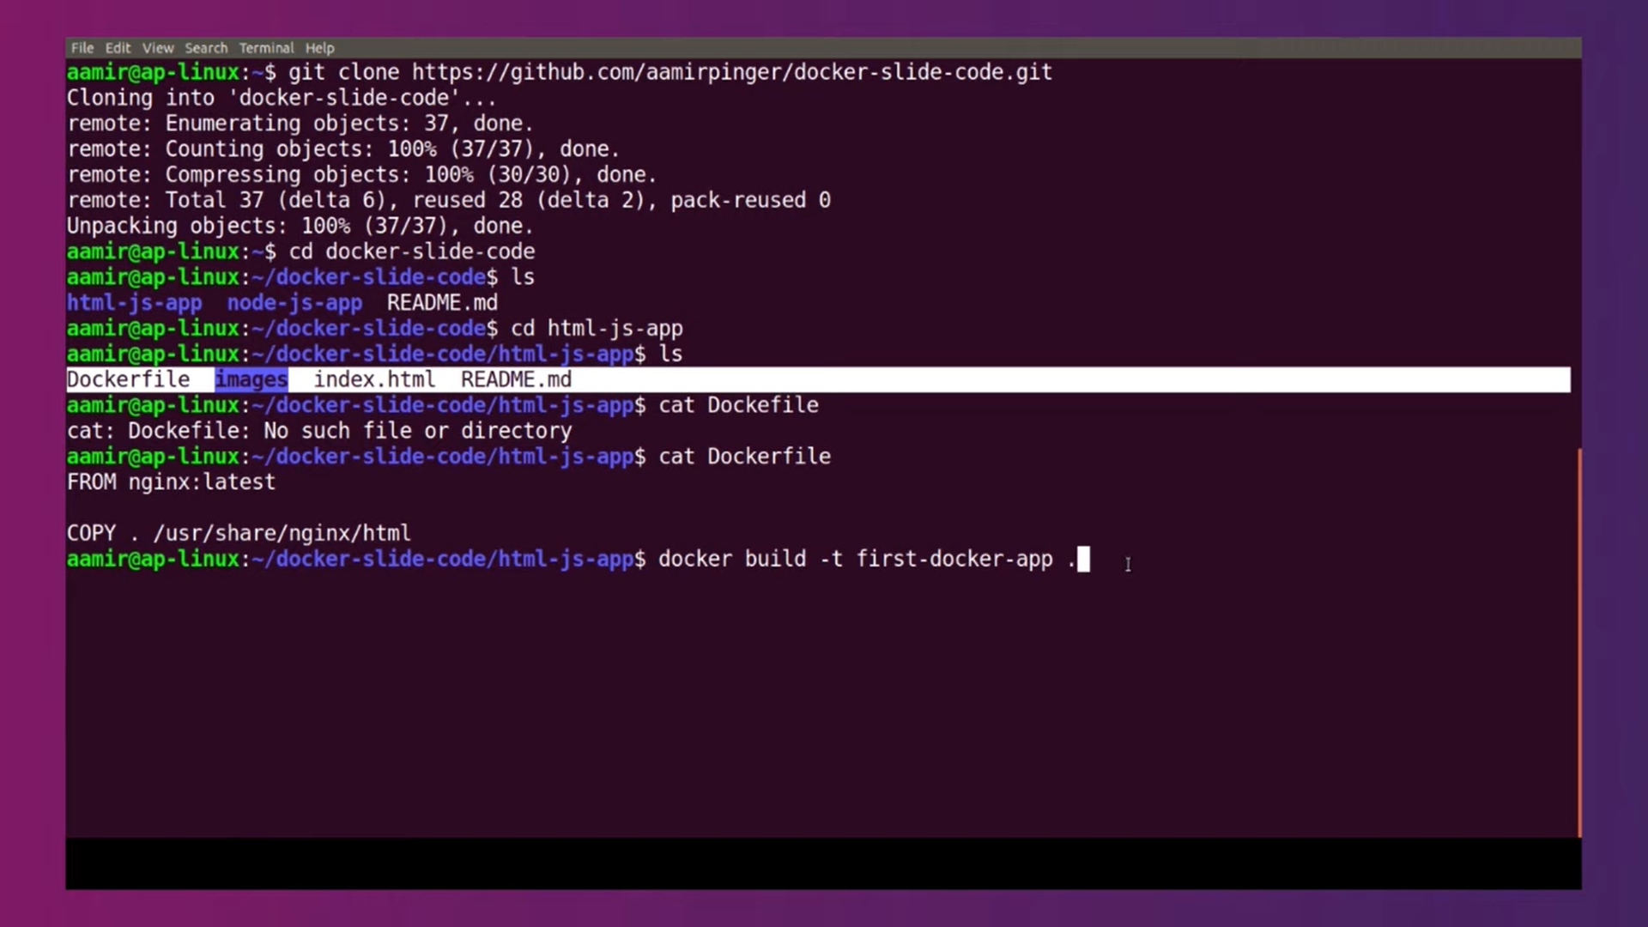

**24. Containerizing an App (Practical Example 2):**

* If you have already cloned aamirpinger repository, go into another folder: node-js-app.
* You can use the commands: cat Dockerfile (to view the dockerfile) and nano Dockerfile 🡪 Ctrl + X 🡪 Enter (to edit the dockerfile).
* When you are in this directory “node-js-app”,
  + **Command:** docker build -t <image name: node-app-image> .
  + **Command:** docker container run -d --name=first-node-cont -p 3000:8080 node-app-image:latest
* 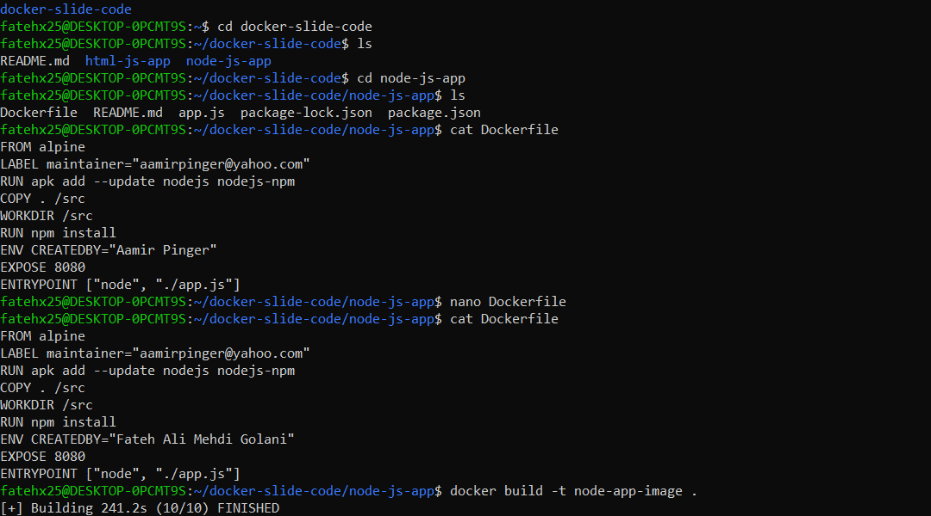
* The internal port number is 8080 by default because we had specified it in our Dockerfile with the command of EXPOSE.
* Now, jump onto the following address in your browser: <http://localhost:3000>

**25. Pushing Images:**

* 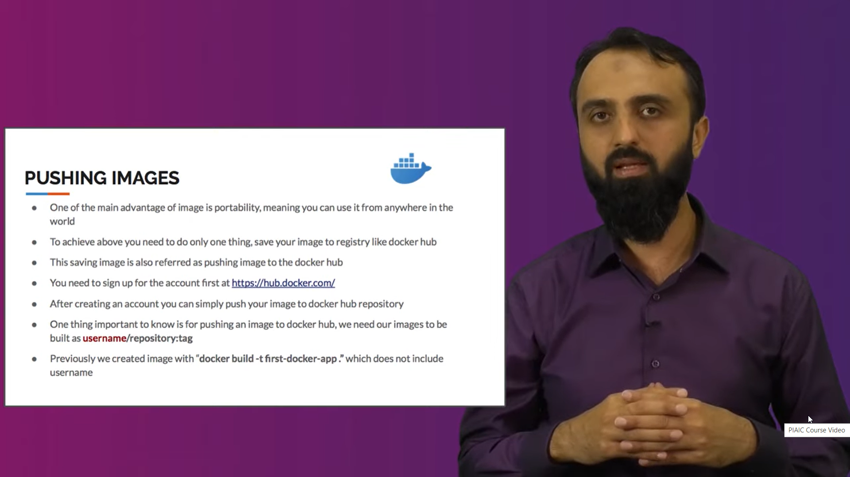
* Just like we used ***docker pull*** command to download the image from Docker hub, we use the command ***docker push*** to upload the image.
* If we implement this command, docker push node-app-image, docker will deny the access since docker would interpret this image to be uploaded in the official registry.



* The solution of the above problem is to add a username with the image name so that the image is pushed into the unofficial registry. However, this gives an error because the image with the tag (username) does not exist locally. There are two solutions:
  + Either to put the username before the image name while creating the image using the command ***docker build***.
  + Or use the command ***docker tag*** which makes a copy of an existing image with a new name. The command is as follows:

docker tag <existing image name> <new name/tag>

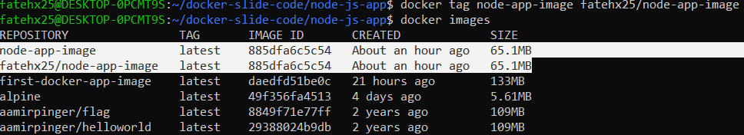

* + Now use the command docker push fatehx25/node-app-image:latest to upload the image successfully.

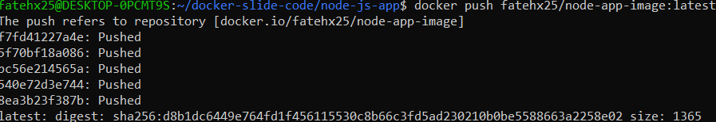

* This is how you make docker images lightweight and portable.

**26. Docker Inspect and Docker History:**

* To view all the relevant information of each layer of an image,
  + **Command:** docker history <image name>
* To view in-depth and complete information of each layer of an image,
  + **Command:** docker inspect <image name>

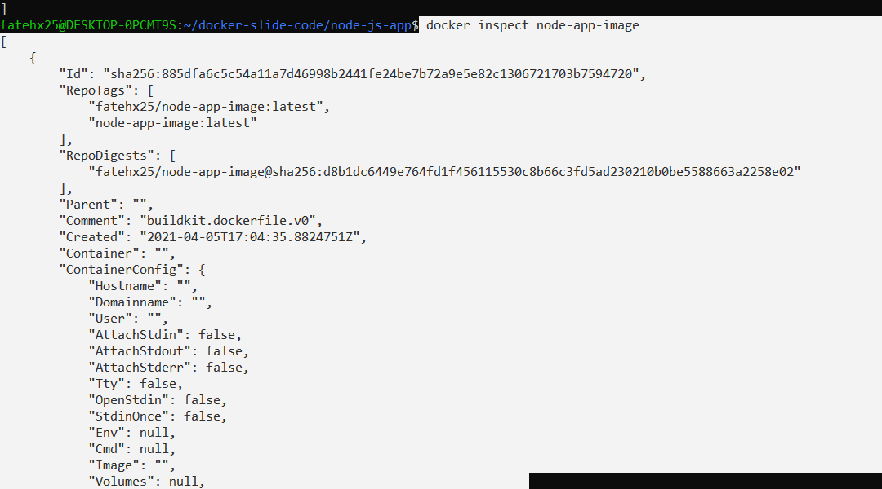

* Image Creation Best Practice: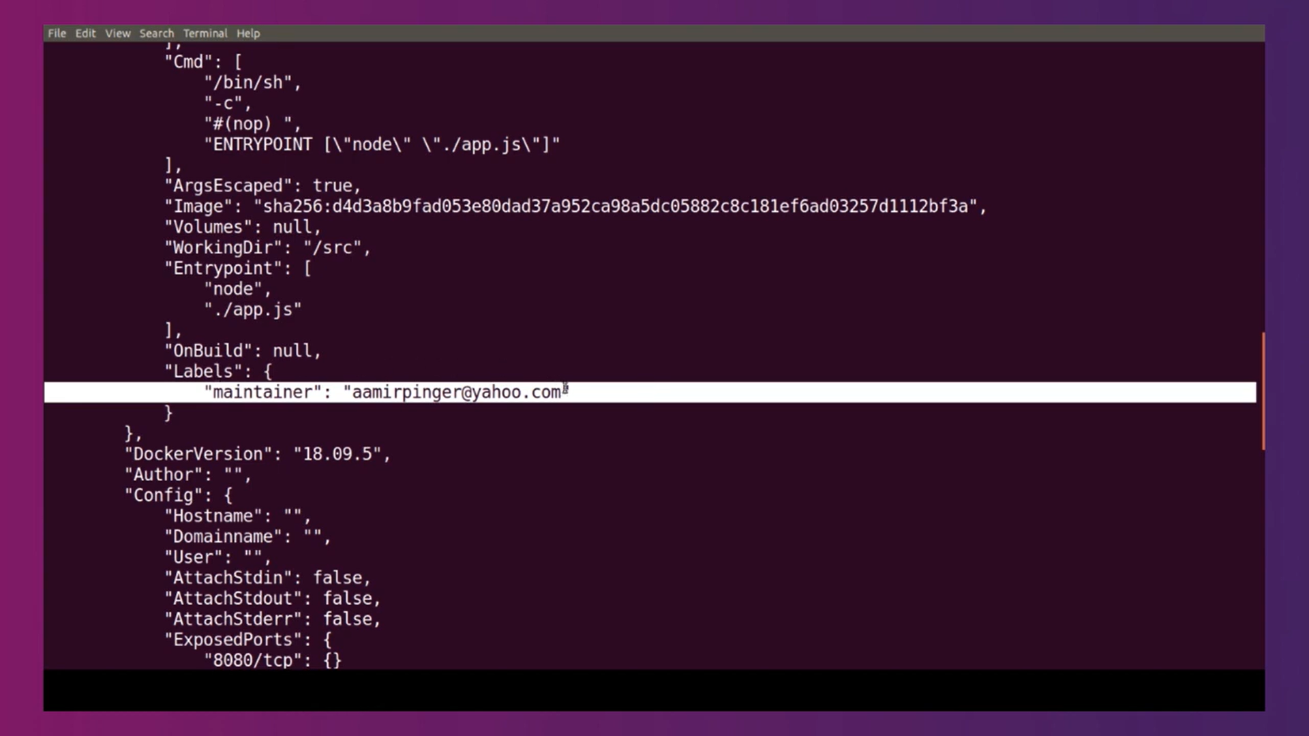

**27. Bind Mount:**

* The newly created files stored in the filesystem of containerized app will not restore once the container is deleted. So, for the files to remain in the host machine even after the containers are stopped, Docker gives us three ways: **Volumes**, **Bind mounts**, **Tmpfs mount** (if running docker on Linux).
* 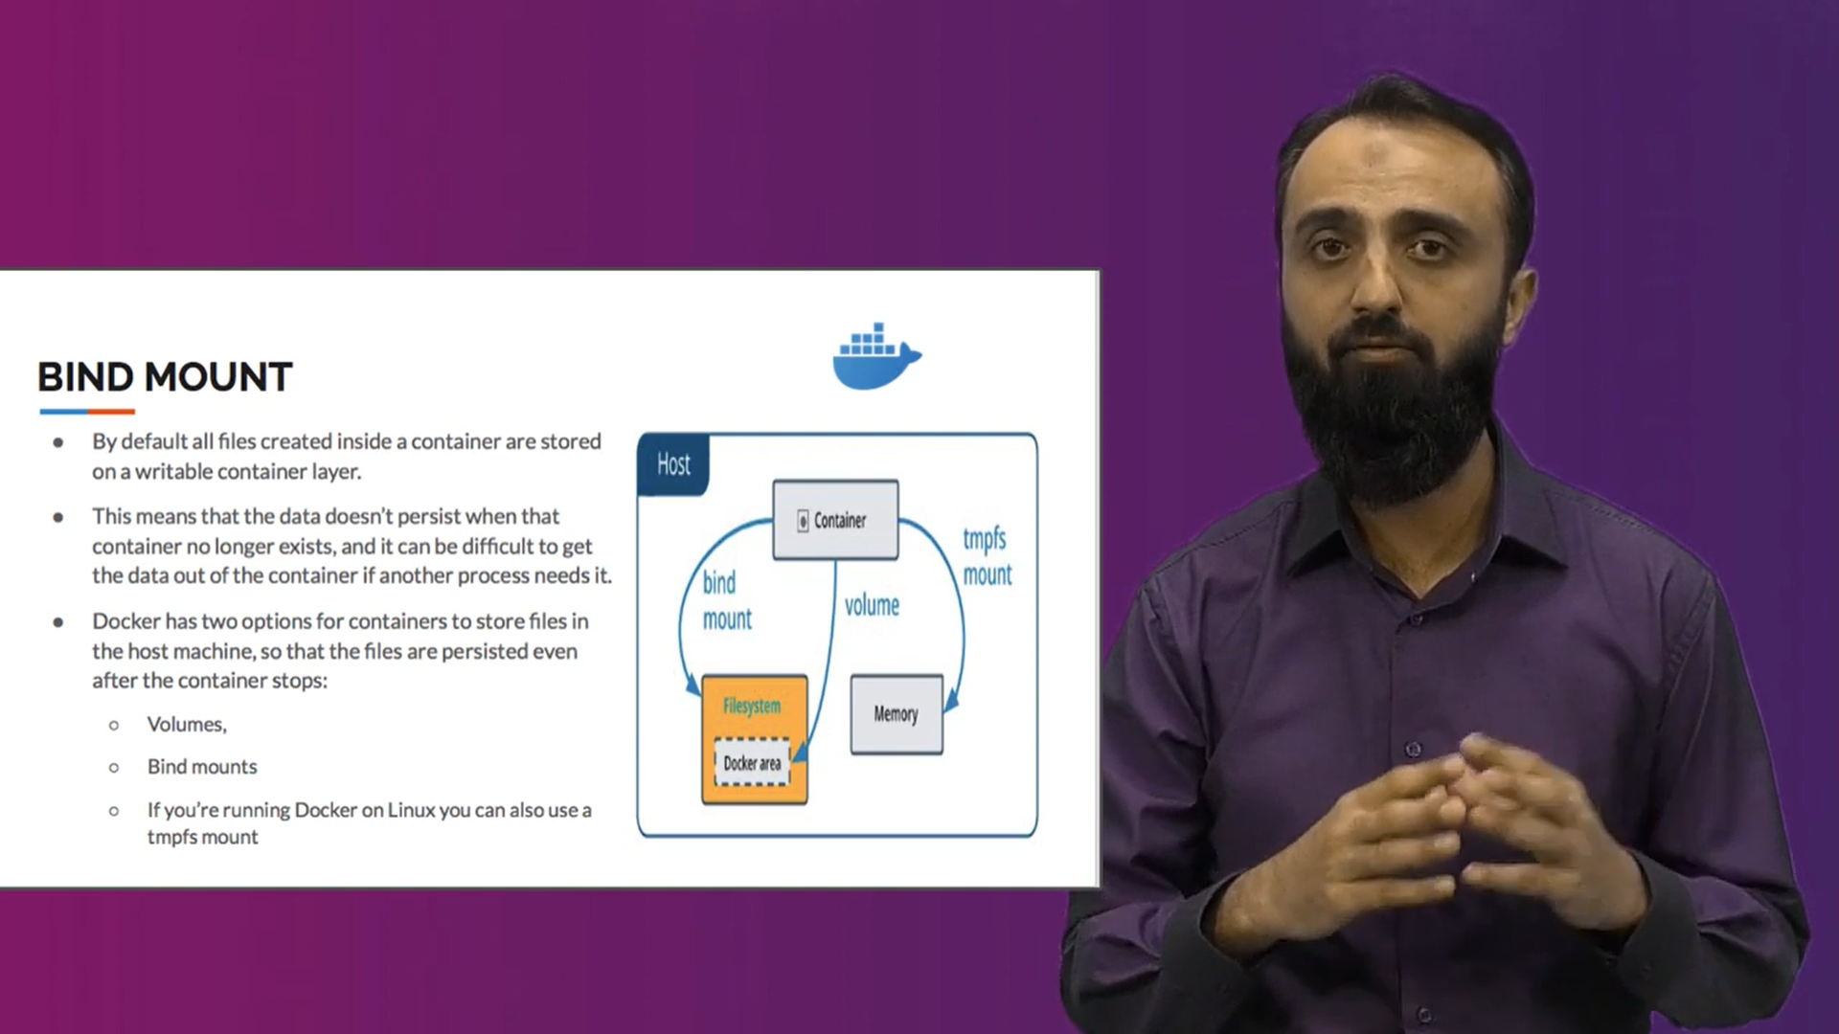
* If the job of one container is to make log files, and the job of another container is to read those created log files and further use them, both of those containers have to use a common filesystem via **bind mount** to communicate the data (files).
* **Bind mount** is a toolwhich becomes alive when one particular folder of thelocal filesystem (of host/server system) is mounted to the filesystem of the containerized app.
* This is the same concept that works when OS makes files and directories on a storage device that is made available to the user through computers file system. This is known as **mounting** a storage device into a system’s OS.
* 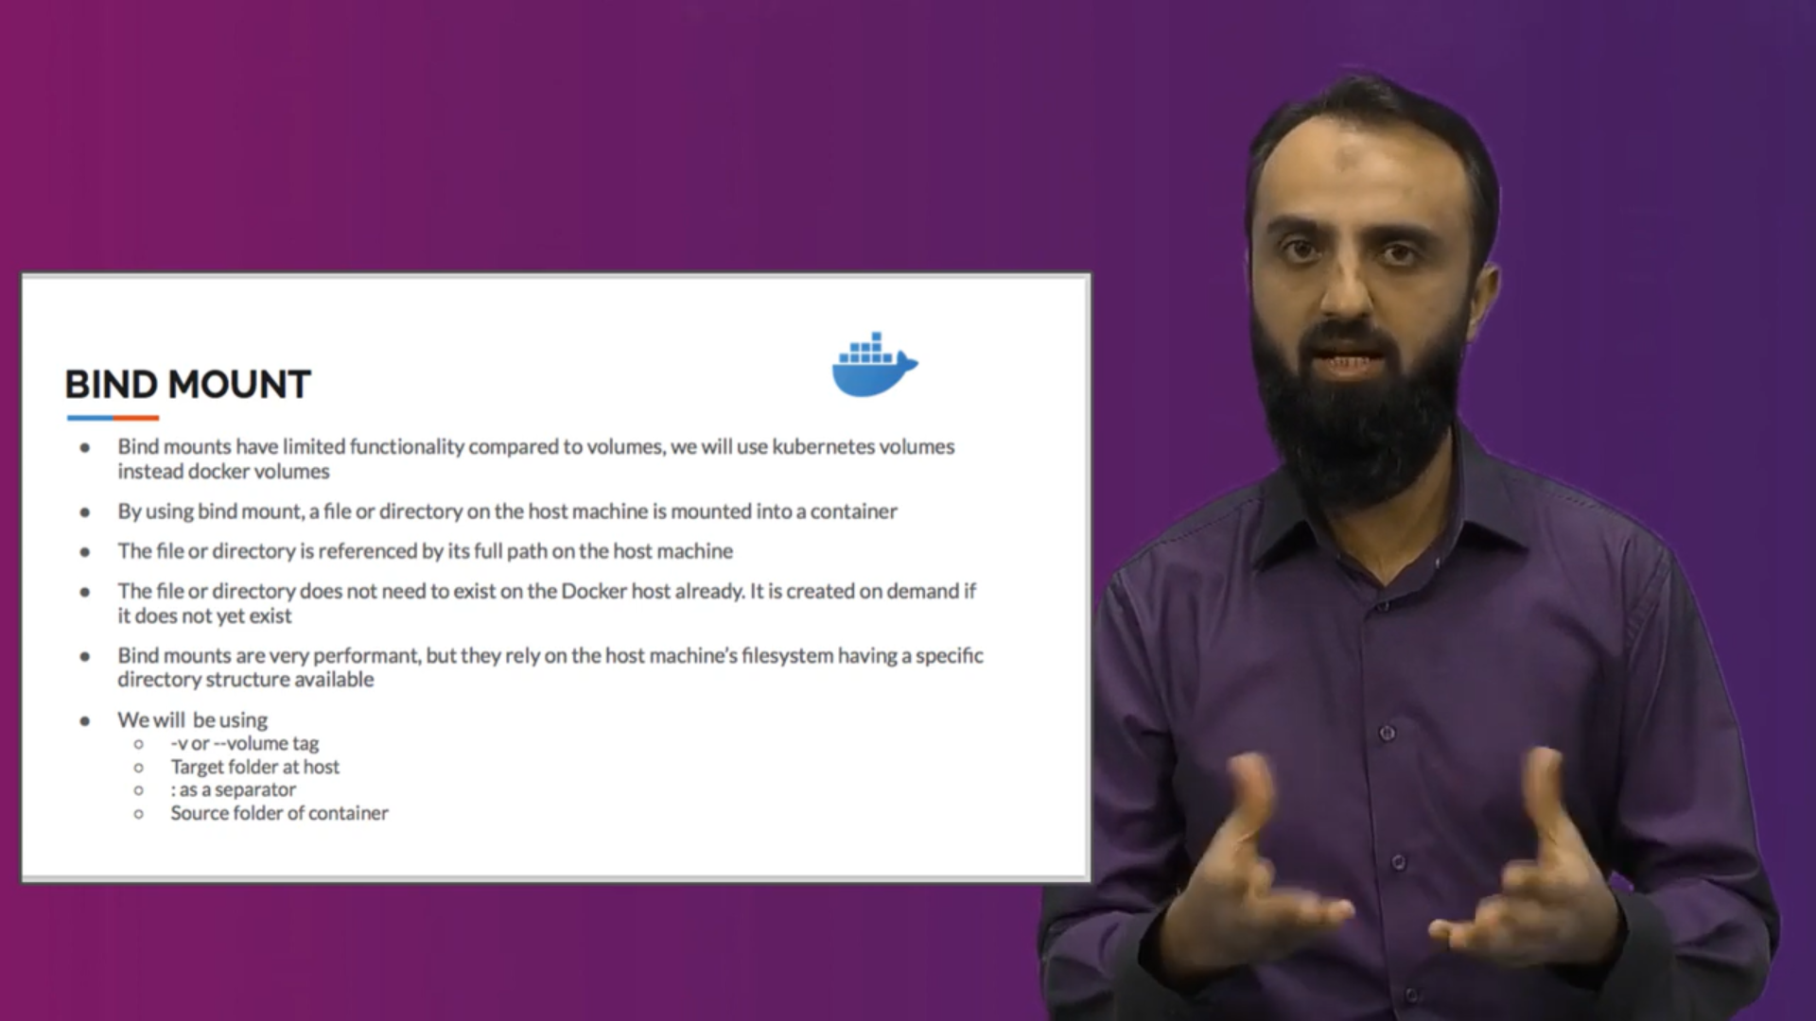

**28. Bind Mount (Practical Example):**

* **Command:** docker container run -it --name=bind-mount-cont -v /home/bind-mount-host:/bind-mount-contapp aamirpinger/helloworld sh
* **Command analysis:** docker container run -it --name=bind-mount-cont -v <folder path in host machine>:<folder path in containerized app filesystem> <image name> {*shell*}
* We command **docker** to **run** a **container** in an **interactive** mode. We give the container a **name**. To mount sever/host’s folder to the container filesystem, we provide the **folder path of host system** and the **folder path of the containerized app filesystem** separated by a **separator**. Then we provide the **image** from which container has to run. Using ‘**sh**,’ we go right into the filesystem of the containerized app.
* 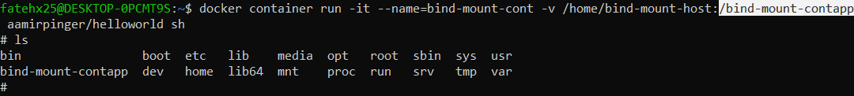
* **Command (To write a text file into a folder in Linux): echo** <text> **>** <file_name.txt>
* 
 